04/12/2022
Jed E. Fazler; Nicholas A. Samuda; Noah E. D. Moffeit; Robert D. Smith
FAMU-FSU College of Engineering 2525 Pottsdamer St. Tallahassee, FL. 32310

Team 504: Smart Projectile
1/14/2022

Abstract
Team 504 is creating a missile with a rotating and deflecting nose for the Florida Center for Advanced Aero-Propulsion. Missile technologies often use fins to control the missile. Control using these fins demands they rotate against high forces, which means they need powerful and large motors to run and that uses extra space. Removing the fins clears up space within the missile, creating more room for things like fuel or electronics. Because of the benefits of finless missiles, our team is looking into new methods of flight control without using fins.
The nose of the missile shows promise when used as a way to improve mobility. The nose directs the air around the missile, allowing for it to pass over the missile smoothly. This means that all high-speed missiles need to have a nose cone. Compared to fins, a rotating nose needs less power to move at high speeds; meaning the motors will need less space in the missile. Thus, adjusting the nose is an ideal choice for improving missile control. Our goal is to create a rotating nose cone model that allows for control without using fins.
Team 504 will test the model in the lab to understand the benefit of the rotating nose for control. To control the nose, internal motors connect to a controller found outside the tunnel. By connecting the model to the computer, the nose moves during wind tunnel testing. Using existing software and coding, the influence of the rotating nose on the missile control can be seen using advanced techniques. Our tests will show a picture of how the air moves near the missile nose to better understand the changes caused by the nose rotating. Our results allow for the comparison between the moving nose effectiveness to the rotated fins.

Acknowledgment

Team 504 would like to thank all those that helped in the completion of the Smart Projectile project. Special thanks to our sponsor, Dr. Rajan Kumar, for providing this project to the FAMU-FSU College of Engineering, mentoring our team, and allowing our team to work on and learn from this project.
We would also like to thank Dr. Jonas Gustavsson and Dr. McConomy for advising us throughout the entirety of the project. Dr. Jonas Gustavsson guided us through every bump along our way and provided our team with every resource needed for our designs. Dr. McConomy provided our team with advice on the design process and assisted with the development of our professional presentation skills. Both advisors played critical roles on the development and completion of this process.
Additional thanks to Jeremy Philips for advising our team on the design and machining of our model. Without Jeremy Philips, there would be no model for testing and the success of the project is in large part due to him and the FCAAP machine shop. We would also like to thank the Air Force Research Lab (AFRL) for providing our team with components for testing. Due to the lack of the necessary facilities to produce multi-filament prints, AFRL’s contributions providing us with their own sleeves were very helpful in the completion of our project.
Lastly, we would like to thank everyone else that helped us along the way. This includes, but is not limited to, Dr. Roopesh Kumar, Nycholas Gierhan, Jayson Dickinson, Jordan Noyes, Joseph Thyer, and Joshua Jones. All those listed provided us with helpful advice and assistance throughout the design process and were critical in our success.
Table of Contents
Abstract ii
Acknowledgment iii
List of Tables viii
List of Figures x
Notation xi
Chapter One: EML 4551C 1
1.1 Project Scope 1
1.2 Customer Needs 3
1.3 Functional Decomposition 5
1.4 Target Summary 10
1.5 Concept Generation 14
1.6 Concept Selection 16
1.8 Project Alterations 25
1.9 Spring Project Plan 26
Project Plan. 26
Build Plan. 27
Chapter Two: EML 4552C 28
2.1 Restated Project Definition and Scope 28
FAMU-FSU College of Engineering 30
2.2 Final Design 30
2.3 Results 31
2.4 Discussion 32
2.5 Conclusions 33
2.6 Future Work 34
2.7 References 34
Appendices 36
Appendix A: Code of Conduct 38
Appendix B: Functional Decomposition 44
Appendix C: Target Catalog 45
Appendix D: Concept Generation and Morphological Chart 45
Appendix D: Binary Pairwise Comparison 57
Appendix E: House of Quality 58
Appendix F: Pugh Charts 59
Appendix G: Analytical Hierarchy Process 61
Appendix H: Operation Manual 66
Overview 66
Project Objective 67
Key Goals 67
Components/Assembly 67
Integration 81
LabVIEW Code 83
Operation 87
Troubleshooting 88
Appendix I: CAD Drawings 90
Appendix J: Spring Project Plan 106
Appendix K: Risk Assessment 107
Appendix L: Calculations 118

List of Tables
Table 2: Customer Interpreted Needs 3
Table 3: Critical Targets and Metrics 14
Table 4: Medium Fidelity Concepts 15
Table 5: High Fidelity Concepts 16
Table 6: House of Quality 19
Table 7: Initial Pugh Chart 20
Table 8: Final Pugh Chart 21
Table 9: Normalized Analytical Hierarchy Process 22
Table 10: AHP Design Alternatives 23
Table 11: Final Rating Comparison 24
Table 12: Final Selection 25
Table : Targets and Metrics Breakdown 45
Table : Morphological Chart 53
Table 11: Binary Pairwise Comparison 57
Table 12: House of Quality 58
Table 13: Initial Pugh Chart 59
Table 14: Second Pugh Chart 59
Table 15: Final Pugh Chart 60
Table 16: Analytical Hierarchy Chart 61
Table 17: Normalized Analytical Hierarchy Chart 61
Table 18: Consistency Check 63
Table 19: AHP Provides Power for Components 63
Table 20: Final Rating Matrix 64
Table 21: Criteria Weights 64

List of Figures

Figure 1: Functional Hierarchy Chart 7
Figure 2: Final model design in non-deflected (top) and deflected (bottom) configurations. 31
Figure 3: Benchtop Testing Setup 32
Figure 4: Medium Fidelity Concept #1: Movable internal mass 54
Figure 5: Medium Fidelity Concept #2: Side Thrusters with Pulsating Jets 54
Figure 6: Medium Fidelity Concept #3: Side thrusters with vortex generators 54
Figure 7: Medium Fidelity Concept #4: Rotating Nose Cone 55
Figure 8: Medium Fidelity Concept #5: Gill Intakes 55
Figure 9: High Fidelity Concept #1: Articulating nose cone with plasma actuators 56
Figure 10: High Fidelity Concept #2 - Articulating nose cone with microjet actuators 56
Figure 11: High Fidelity Concept #3: Movable internal mass with a sparkjet actuator 56

Notation
AFOSR | Air Force Office of Scientific Research
AIAA | American Institute of Aeronautics and Astronautics
AFRL | Air Force Research Lab
FCAAP | Florida Center for Advanced Aero Propulsion
LSWT | Low Speed Wind Tunnel
PIV | Particle Image Velocimetry
PSP | Pressure Sensitive Paint

Chapter One: EML 4551C

Project Scope
Project Description
This project aims to create a technology that can be applied to many projectile
configurations, allowing the projectile to maneuver adaptively through unforeseen, hazardous
environments. The technology developed will detect said obstacles or conditions and actuate the
projectile autonomously.
Key Goals
The key goals were selected to itemize the main objectives that must be accomplished
over the duration of the project based on the project’s description and advice from the project’s
sponsor. The following are the goals or milestones we have derived to ensure the project’s
completion:
- Conceptualize and research 5 different innovative ways to maneuver a projectile.
- Choose one of these designs to expand upon and develop into a working design.
- Develop innovative technologies that can be implemented into the projectile allowing for smart capabilities.
- Develop a way for the projectile to adapt to its environment or obstacles through
- autonomous actions.
- Construct a scaled down model of the projectile for use in wind tunnel testing t0 verify desired aerodynamic characteristics of design.
- Construct a prototype projectile to test actuation of the smart functionality withinthe projectile.
Market
The primary market for this project was seen as the company or organization that the
product would be directly constructed for and would use the product. The secondary markets are
a makeup of other companies or organizations who may benefit from or would be interested in purchasing the results of this project.
Primary Markets:
- Florida Center for Advanced Aero Propulsion (FCAAP)
Secondary Markets:
- Air Force Office of Scientific Research (AFOSR)
- Lockheed Martin
- Raytheon Technologies
- Northrop Grumman
Assumptions
The assumptions for this project were made to limit the scope and to focus the team’s
effort into the correct areas for our project. It is assumed that the projectile deployment, entailing
storage, transportation, and initial launch, will be facilitated by technologies already
implemented in the projectile. It is also assumed that the projectile will remain within earth’s
atmospheric conditions for its use.
Stakeholders
The stakeholders for this project include all parties who will have influenced the design
of the technologies produced by the project as well as those who have invested time and other
resources into the project. This includes those who have contributed to the specifications of the
project as well as those who would benefit from the research performed and technology created.
The stakeholders for this project are listed below:
- Dr. Shayne McConomy
- Dr. Rajan Kumar
- Dr. Jonas Gustavsson
- FCAAP
- FAMU-FSU College of Engineering

1.2 Customer Needs
FCAAP has partnered with the FAMU-FSU College of Engineering to develop a smart projectile, and advance current projectile technology. FCAAP has connected us with Dr. Jonas Gustavsson who acts as our main liaison to the FCAAP organization and has provided the answers in response to the following questions.
Table 2: Customer Interpreted Needs
Questions | Responses | Interpretation
- How do you think current control surfaces and their actuation can be improved? | Current control surfaces require clean flow, which is not realistic at high angles of attack, so that’s something. | Projectile accommodates for attached flow over control surfaces.
- What draw backs come with standard fin deflections as a control surface? | Must have clean flow to actuate properly. Size and weight that come with actuation mechanism | Projectile control surfaces will be suitable effective even in detached flow.
- What Mach numbers would be expected for this projectile? | FCAAP polysonic wind tunnel can’t go faster than Mach 5. We’ll probably test Mach 4. | The projectile can withstand Mach 4.
- What slenderness ratio of the projectile would be appropriate? | Would be nice if it could be tied into what we have done already. Matching a baseline design here at FCAAP. 8-10 | The projectile uses a basic axisymmetric body configuration based on previously tested models.
- Do we need to worry about designing the method of propulsion? | Don’t worry about designing the propulsion as we cannot have it modeled in the wind tunnel. | Propulsion is beyond the scope of this project.
- By the end of this project, what level of manufacturing should be accomplished to demonstrate our results? | Small model for testing control surfaces in wind tunnel, larger model for demonstration purposes and sensing capabilities. Radar sensors possible option. | The projectile is modelled for aerodynamic testing and then prototyped for proof of actuation.
- What conditions do you expect the projectile to operate in? | Projectile should go where the target goes. High angles of attack. Initial deployment shockwaves and vortices. Vibrations in supersonic can affect and disrupt the electronics. | The projectile has a way to rapidly adapt to the conditions that exist during deployment.
- Should the projectile be able to actuate without user input? | Yes | The projectile is automatically operated.
- Should favorable aerodynamic characteristics be prioritized over functionality? | No, it should accomplish the task while minimizing negative effects. Compare to previous results. | Maintaining aerodynamic characteristics is secondary to maintaining control surface effectiveness.
- What is considered a “harsh” or “hazardous” | Vortices, and shockwaves off the parent aircraft. High angles of attack | The missile adapts to high pitch angles.
- What will be the preferred method of flow visualization? | It looks good. Better for showing actuation effects. Could be done with shadow graph in the wind tunnel. Not necessary but helpful. | Flow visualization will be done through other tests such as shadowgraph or oil flow.
- Will the projectile also have to accommodate targeting? | Does not necessarily need to sense targets, could also sense high angles of attack. | The missile can sense its angle of attack in various scenarios.
To generate Table 2, our team looked at the project brief we had been given and the notes taken from our meetings with our sponsor and advisor. These resources were used to generate a list of questions that would help refine our project scope. During our meeting with our sponsor, our team asked our questions and recorded condensed versions of their responses in Table 2 above. The interpretations for each of their responses was then discussed as a group and determined for each response.
From our interpretations, we were able to extract the primary needs for our project. Our project will need to produce two physical products: a model to verify the aerodynamic characteristics, and a prototype to verify the actuation systems. Our projectile is expected to travel at Mach 4 and our design needs to be based around previously tested models in which we have data to compare to. The designed projectile will be capable of sensing its conditions and rapidly adjusting to fix them autonomously. Based on these interpreted needs, our project scope will be further refined, and we will break our project down into functions.

1.3 Functional Decomposition
Introduction
The functional decomposition is the development of our needed systems based on the information provided from the customer. The functional decomposition attempts to arrange all our interpreted customer needs into a form where we can determine which systems are required for accomplishing the goal of our project.
Data Generation
Through the analysis of everything we have learned regarding our project so far, we set out to determine what necessary functions were required for our project. Following a discussion with our advisor, we managed to break our project down into four main systems. Following this, we developed minor functions and functions such that our project could meet our needs.
Hierarchy Chart
The hierarchy chart displayed in Figure 1 represents the overall functional breakdown of our project. Our project has four main systems: sensing, actuation, structure, and power.
The sensing system is responsible for everything related to sensors and how they interpret and use the data. The actuation system controls everything that will alter the projectiles movement or operation. The structure system pertains to everything related to the mechanical capabilities of the materials used for the design. The power system is responsible for the containment and use of the power in the system. These systems were generated to fully accomplish the customer needs determined for our project. With our actuation and sensor systems, we manage to cover the needs related to flow control and the sensing/response required. Through the structure system, we can ensure we meet the need of Mach 4 capabilities.

Figure 1: Functional Hierarchy Chart
The sensing system has two subsystems of sensors and signaling. The sensor subsystem contains the function of monitoring the sensor data. The signaling subsystem contains the functions of interpreting the data read by the sensor and transmitting a response signal when required. The interpreting data refers to analyzing the sensed data trying to detect issues and transmitting the signal corresponds to the response to the interpreted error.
The actuation system is comprised of two different subsystems: mechanical and flow. The mechanical subsystem is responsible for the required mechanical actuation functions such as controlling the pitch, roll, and yaw. The subsystem of flow is responsible for the function of maintaining the flow attachment.
The structure system is divided into two functions: maintaining the integrity of the body and protecting the components.
The power system is split into the two subsystems of storage and transmission. Within the storage subsystem, the project accomplishes the function of providing the power for operation. The other subsystem is transmission which contains the function of transferring power to the components.
Connection to Systems
The Sensing system will have the main objective of obtaining, interpreting, and transmitting sensor data to a controller, and then to the actuation systems. The control of pitch, roll, yaw, and flow attachment will consider sensor data, and thus are intertwined with the sensing system, but more directly under the actuation system. The Actuation system causes the physical action that will be taken to replicate a desired output of our missiles conditions. The transmission of power from the supply are seen as a supplemental part of the actuation system. The Structure system consists of the main body of the projectile and is responsible for maintaining integrity of the outer body, as well as protecting internal components. The flow attachment of the control surface also falls under the structure system. The Power system will store the energy necessary to power all electronic systems, as well as the means of transmitting the energy. This transmission of power is also applied to the transmission of signal data from the sensors.

Cross Reference Table
System Functional Decomposition
Function | Sensing | Actuation | Structure | Power
Monitors sensor data | X
Interprets sensor data | X
Transmits sensor data | X |  |  | X
Controls pitch | X | X
Controls roll | X | X
Controls yaw | X | X
Maintains flow attachment | X | X | X
Maintains integrity |  |  | X
Protects components |  |  | X
Provides power for operation |  |  |  | X
Transfers power to components | X | X |  | X

Smart Integration
Transmitting sensor data will require two sub-systems, one being sensing and the other being power. This is because it requires power to send signals from the sensors. Controlling the pitch, roll, and yaw of the projectile will require the sensors system to determine the projectile’s current location and future destination, and to control the direction, the actuation system will be required. Maintaining flow attachment will require three sub-systems: that being the sensing, actuation, and structure. This is because the projectile will have to sense when the flow will detach and actuate to prevent that. Flow detachment may also be prevented through special design of the structure. Another function that will require three sub-systems is transferring power to components. This is because the sensors and actuators will all need power.
Action and Outcome
The smart projectile will be capable of flying in a variety of conditions including at high angle of attacks. This includes the capability of sensing its surroundings and the ability to adjust its flight path to achieve its goal. To accomplish this, the projectile will need various control surfaces to adjust its pitch, roll, and yaw. To maintain useable control surfaces at high angle of attacks, a way to keep the flow attached will also be included. Maintaining flow attachment will require three sub-systems as it requires sensing to determine if the flow is detached, actuation to either reattach the flow or ensure the flow does not detach, and lastly structure as this system will determine where the flow may detach. Transferring power to components will also require three sub-systems: sensing, actuation, and power.

1.4 Target Summary
Introduction
The targets and metrics are critical for determining the success or failure of the project in the end. The targets consist of a critical targets and general targets. The critical targets are those that will be used at the end of the project to determine whether our project succeeded. These critical targets are highlighted in our target catalog shown in Table 4. The general targets are not considered critical to the success of the project to achieve but are parameters that will be designed around. Given the research-based nature of our project, our targets are largely based on what characteristics we would like to see to prove that our hypothesis was correct.
Method of Validation and Measurement Tools
The validation of the target with regards to “Maintains Integrity” will be accomplished by first completing a CAD model of the projectile that may be used inside of the Polysonic Wind Tunnel. Finite element analysis will then be conducted, applying the targeted static pressure of 9.6 psig (corresponding to a tunnel speed of $M=4$) and determining the corresponding von mises stresses and factor of safety across the entire body.
Validating that the control of the pitch, roll, and yaw perform as expected will be determined though wind tunnel testing of the model. A 6-cell force balance will be used within the model to determine the aerodynamic characteristics of the model. Within the wind tunnel, the model will be able to sweep through a range of attack angle allowing for data collection through the force balance. The data recorded by the balance will be processed through MATLAB to derive the aerodynamic coefficients and verify our targets.
To validate the sensing technology, an Arduino or data acquisition card (such as a USB 6008) will be used to determine the response time of the signal. A flag can be set within the code that marks the point at which data is received while another flag marks when the corresponding actuation is performed. The difference between these two flags will provide the response time for the interpretation of the signal.
Derivation of Targets and Metrics
Multiple methods were used in the derivation of the targets. Our project’s systems were broken down into subsystems that corresponded to functions. Competitive benchmarking was implemented by referring to previous technical articles discussing the properties and qualities of axisymmetric configurations. These properties were used as a baseline for what is expected of the projectile.
Sensing Targets and Metrics
The targets developed for the sensing system pertain to the three main functions of monitoring sensor data, interpreting sensor data, and transmitting sensor data. The target for monitoring sensor data was determined to be 1 millisecond. This comes from the average response time for pressure transducers, which will be used in this project to monitor flow attachment or altitude (OMEGA). The target for interpreting sensor data was set to be 300 milliseconds. This was based on the time it takes for car assistance systems to sense an object and respond (Piao & McDonald, 2008). Due to the lack of published information regarding the processing and response time of missile, we are assuming that the sensing technology would need to be able to adapt within the same time frame as an assisted driving system would have to make an emergency stop. The final target is for transmitting sensor data. This target was also determined to be 1 kHz. This is the rate at which the computer will transmit the data to the controls system which was determined by the analog output frequency allowed by many standard electronic boards such as an Arduino.
Actuation Targets and Metrics
The targets developed for the actuation system are in relation to the four main subsystems. For controlling flow attachment, flow is desired to be controlled up to 24°. This is based on the consideration that an angle of attack above 15° is considered high and will induce flow detachment for most bodies. The second target developed was for controlling the maneuverability of the projectile by means of the pitch, roll, and yaw. With respect to the moment coefficients, a CPM and CYM of 3.2 and a CRM of 0.8 are the targets. These values were determined from previous tests of a basic axisymmetric missile configuration that utilized fins at ± 20° deflection (Kumar, Guha, & Kumar, 2020).
Structure Targets and Metrics
The pressure applied to the body of the projectile is assumed to be around 9.6psi at Mach 4. This target was determined based on the specifications of the Polysonic Wind Tunnel and previous calibrations performed by the tunnel engineer. The projectile and its control surfaces will need to be able to withstand this pressure to maintain integrity, as well as protect the internal components.
Power Targets and Metrics
The power source for the projectile is one that would allow for at least 60 minutes of operation. This is to match the typical flight time for a Low Cost Missile System (Time Critical Conventional Strike from Strategic Standoff, 2009). With regards to the transfer of power .
Targets and Metrics Outside of Functions
Additional targets outside of the functions described will include achieving a CL/CD ratio of 2.6. The CL/CD ratio is an aerodynamic performance ratio that depicts how the design performs with respect to lift and drag. A value of 2.6 was chosen based off previous research on a well-tested basic axisymmetric model (Dawson, Kumar, Parker, & Taylor, 2018).
An additional target was set to keep an L/D ratio of 10.5. This was chosen as it allows for results obtained from the wind tunnel to be directly comparable to previously studied bodies (Kumar, Guha, & Kumar, 2020).
Furthermore, to ensure the model will be safe to test inside of the Polysonic Wind Tunnel, a sting mounted version of the CAD must be tested using FEA and allow for a factor of safety of at least 2. By producing this factor of safety, this ensures that the tunnel test will not damage the sting or force balance that are used to take force measurements.
Summary
A summary of our critical targets and metrics is given in Table 3. This consist of all the targets deemed critical to the success of our project. All our targets were derived from previously performed research as well as with standard components specifications and standards. Throughout the design process, our targets would be used as design parameters that we prototype and alter our design to fit. In case target readjustments are required later on in the design process, a group meeting will be held and reasoning will be given as to why the targets need to change from their original values.
Table 3: Critical Targets and Metrics
System | Function | Target | Metric
Sensing | Interprets sensor data | 300 milliseconds | Time
Actuation | Controls pitch | CPM $≥$ 3.2 [Unitless] | Coefficient of Pitch Moment (CPM)
Actuation | Controls roll | CRM $≥$ 0.8 [Unitless] | Coefficient of Roll Moment (CRM)
Actuation | Controls yaw | CYM $≥$ 3.2 [Unitless] | Coefficient of Yaw Moment (CYM)
Structure | Maintains integrity | $$σ_{s}=3\left(9.6 psig\right)$$ | Factor of safety

1.5 Concept Generation
Introduction
Concept generation was performed for this project to provide the team with relevant concepts that encompass a wider range of ideas than what was possible with just brainstorming. To do so, the team employed a variety of concept generation tools to come up with 100 concepts that can be found in Appendix D . These concepts will later be narrowed down during the concept selection process.
Generation Tools
Generating our 100 concepts necessitated the use of different concept generation tools. The first of these tools that we used was brainstorming. Brainstorming is one of the most common tools used to come up with ideas. Through the use of the SCAMPER method, brainstorming resulted in more focused and directed ideas. Specifically, the team utilized the “combine” and “rearrange” parts of SCAMPER to come up with many of our ideas. Following brainstorming, the team used biomimicry to come up with ideas based on nature. Biomimicry resulted in a significant amount of our teams’ ideas as nature contains many examples of aerodynamics and flow control. Following biomimicry, we used a morphological chart (Table 5) to create the remainder of our ideas. The morphological chart was made based on parts of our functional decomposition that we broke down into basic ideas that could be combined to produce 44 ideas.
Medium Fidelity Concepts
Our medium fidelity concepts were chosen as concepts we liked the ideas of but did not want to fully evaluate as our project. These ideas excel in specific objectives of our project and will act as a reference point for how well our high-fidelity concepts achieve these goals. These ideas are displayed in Table 4 below and are sketched in Appendix D.
Table 4: Medium Fidelity Concepts
Concept # | Concept Description
7 | Controllable internal mass that can move throughout the body and change the aerodynamic characteristics.
80 | A projectile that controls flow using a pulsating jet and uses side thrusters for mechanical control.
95 | A projectile that uses vortex generators to control flow and side thrusters for mechanical control.
28 | Rotating nose cone to induce circulation in the flow and generate forces.
49 | Gill-like intake to allow for storage of air and creation of a pressure cavity that can be used to push up flaps that induce vortices.
High Fidelity Concepts
Our high-fidelity concepts consist of the ideas the team is the most interested in investigating for the project. We selected three high-fidelity ideas that we believed best encompassed the scope of our project and would provide the best results. These ideas are listed in Table 5 and are sketched in Appendix D.
Table 5: High Fidelity Concepts
Concept # | Concept Description
58 | A projectile that controls flow using plasma and uses an articulating nose cone for mechanical control.
59 | A projectile that uses microjets for flow control and uses an articulating nose cone for mechanical control.
73 | A projectile that controls flow using sparkjets and uses internal mass for mechanical control.

Moving on, our team will analyze our concepts and decide upon a design that we will propose to our sponsor, Dr. Kumar, to continue our project with.

1.6 Concept Selection
Introduction
To select our concept for our design, a multi-stage analytical process was used to mathematically reduce our number of concepts down and eventually, select the final concept. The process by which this occurs is outlined throughout the rest of this section.
Binary Piecewise Comparison
The binary piecewise comparison was performed first to ascertain the relative importance of each customer need. To do this, each customer need was placed across the first row and down the first column such that each customer need was reflected across the diagonal. Then, each row was compared against its column and assigned a 1 or a 0 depending on whether it was more important or less important respectively. The binary piecewise comparison for our project is shown in Table 8 in Appendix D. The rows of the chart were then summed to form the importance weight factor for each customer need, representing which of the customer needs are of more importance to attain.
House of Quality
The next stage of the concept selection process was the house of quality. The house of quality is useful in infusing the voice of the customer into the design process. An important part of concept selection is knowing which of your engineering characteristics are the most crucial for the design. The house of quality compares each customer requirement to our engineering characteristics and evaluates how much influence the customer requirement has on the engineering characteristic. A value of 1, 3, or 9 is then assigned based on how critical the requirement is to the characteristic with a 1 being needed and 9 being critically needed. Each requirement was also provided an importance weight factor that was determined from the binary pairwise comparison. Each row was then multiplied by the importance weight factor and then the columns were summed to obtain a raw score for each characteristic. A relative rank was then found by dividing each characteristics raw score by the total raw score. The house of quality is displayed in Table 6. The characteristics were then ranked in order from most important to least important. The most important characteristic was to control the flow attachment, followed by the time to interpret sensor data, the amount of voltage provided to the components, the time to monitor sensor data, the time to provide power to components, then the frequency of the sensor data and the control of the aerodynamic moment were tied for sixth place, and finally the least important was to protect the internal components.
Table 6: House of Quality
 |  | Engineering Characteristics
Improvement Direction |  | ↑ | ↓ | ↓ | ↓ | ↑ | ↑ | ↑ | ↑
Units |  | Time (mins) | Voltage (V) | Time (ms) | Time (s) | Frequency (Hz) | Angle of Attack | Unitless Coefficients | Water Proofing Standards
Customer Requirements | Importance Weight Factor | Provides Power for Components | Transmits Power to Components | Monitors Sensor Data | Interprets Sensor Data | Transmits Sensor Data | Controls Flow Attachment | Controls Aerodynamic Moments | Protects Internal Components
Projectile controls flow separation | 5 | 3 | 9 | 1 | 1 | 1 | 9 | 3
Projectile model is capable of testing at Mach 4 | 1 |  |  |  |  |  | 1 |  | 9
Projectile uses an Axisymmetric Body | 0 |  | 1 |  |  |  | 1 | 3 | 3
Projectile can rapidly adapt to flow conditions | 2 | 3 | 3 | 3 | 9 | 3 | 1 | 1 | 1
Projectile can react automatically | 4 | 3 | 1 | 9 | 9 | 3 | 3
Projectile can adapt to high pitching angles | 3 | 1 | 1 | 1 | 3 |  | 3 | 2
Raw Score (338) |  | 36 | 58 | 50 | 68 | 23 | 69 | 23 | 11
Relative Weight |  | 10.65 | 17.16 | 14.79 | 20.12 | 6.80 | 20.41 | 6.80 | 3.25
Rank Order |  | 5 | 3 | 4 | 2 | 6 | 1 | 6 | 8

Pugh Chart
The Pugh chart is a helpful tool in narrowing down possible designs into a smaller, more manageable group. This allows designers to quickly determine the most promising designs relative to the engineering characteristics that were determined to be the most crucial. Table depicts the initial Pugh chart where all eight of our high and medium fidelity concepts were compared against a datum; determining whether each concept completed a function better (+), worse (-), or as well (S) as the datum. The datum was selected to be a basic cylindrical body that utilizes fin deflection for maneuverability as this design is the most widely used and tested. The sum of each grade was calculated at the bottom of the chart and the concept that performed the worst was discarded and the concept that had the most average performance was selected as the datum for the next Pugh chart.
Table 7: Initial Pugh Chart
Pugh Chart
Function |  | Concept
 |  | #7 | #80 | #95 | #28 | #49 | #58 | #59 | #73
Controls flow separation | Datum (Basic Body with fin deflection) | - | + | S | S | - | + | + | +
Able to be tested at Mach 4 |  | S | S | S | S | - | S | S | S
Axisymmetric Body |  | S | S | - | S | S | S | S | S
Adapts to flow conditions |  | - | + | + | S | - | + | + | +
Reacts automatically |  | S | S | S | S | + | + | + | +
Adapts to high pitch angles |  | + | - | S | - | S | + | + | +
 | Plus (+) | 1 | 2 | 1 | 0 | 1 | 4 | 4 | 4
 | Satisfactory (S) | 3 | 3 | 4 | 5 | 2 | 2 | 2 | 2
 | Minus (-) | 2 | 1 | 1 | 1 | 3 | 0 | 0 | 0

The results from Table 7 determined that the worst concept was #49, and therefore, was cut out as a possible concept. Concept #95 performed only satisfactory for a majority of the comparisons, leading to this concept being chosen as the datum for the next Pugh chart. Further Pugh charts were used and can be found in Appendix F. The final Pugh chart was used to determine which concept will go forward through the Analytical Hierarchy Process.
Table 8: Final Pugh Chart
Pugh Chart
 |  | Concept
Function |  | #7 | #58 | #59 | #73
Controls flow separation | Datum (Concept #80) | - | - | + | +
Able to be tested at Mach 4 |  | + | S | S | S
Axisymmetric Body |  | S | S | S | S
Adapts to flow conditions |  | S | - | + | -
Reacts automatically |  | + | + | + | +
Adapts to high pitch angles |  | S | - | + | +
 | Plus (+) | 2 | 1 | 4 | 3
 | Satisfactory (S) | 3 | 2 | 2 | 2
 | Minus (-) | 1 | 3 | 0 | 1

The final Pugh chart determined that concepts #7, #59, and #73 will be the final the concept to move on in the concept selection process.

Analytical Hierarchy Process
The Analytical Hierarchy Process (AHP) was the final part of the concept selection process that was used to make sure our decisions weren’t biased. In this step, we compared the engineering characteristics to each other and provide them a number (either 1, 3, or 5) based on how we interpreted their overall importance in order to check the overall consistency of our selections seen in Appendix G The values were summed, and a normalized criteria comparison matrix was formed by taking the value of each cell and diving it by its summed value shown in Table 8.
Table 9: Normalized Analytical Hierarchy Process
Normalized Criteria Comparison Matrix [NormC]
Criteria | Provides Power for Components | Transmits Power to Components | Monitors Sensor Data | Interprets Sensor Data | Transmits Sensor Data | Controls Flow Attachment | Controls Aerodynamic Moments | Protects Internal Components | Criteria Weight {W}
Provides Power for Components | 0.042 | 0.092 | 0.024 | 0.056 | 0.022 | 0.023 | 0.050 | 0.043 | 0.044
Transmits Power to Components | 0.042 | 0.092 | 0.146 | 0.167 | 0.196 | 0.039 | 0.083 | 0.130 | 0.112
Monitors Sensor Data | 0.125 | 0.046 | 0.073 | 0.056 | 0.196 | 0.117 | 0.083 | 0.043 | 0.092
Interprets Sensor Data | 0.125 | 0.092 | 0.220 | 0.167 | 0.196 | 0.117 | 0.248 | 0.130 | 0.162
Transmits Sensor Data | 0.125 | 0.031 | 0.024 | 0.056 | 0.065 | 0.117 | 0.083 | 0.130 | 0.079
Controls Flow Attachment | 0.208 | 0.277 | 0.073 | 0.167 | 0.065 | 0.117 | 0.083 | 0.130 | 0.140
Controls Aerodynamic Moments | 0.208 | 0.277 | 0.220 | 0.167 | 0.196 | 0.352 | 0.248 | 0.261 | 0.241
Protects Internal Components | 0.125 | 0.092 | 0.220 | 0.167 | 0.065 | 0.117 | 0.124 | 0.130 | 0.130
SUM | 1.000 | 1.000 | 1.000 | 1.000 | 1.000 | 1.000 | 1.000 | 1.000 | 1.000

Criteria weights were then developed by taking the average of these cells. A weighted sum vector was formed by dividing all of the cells by each respective criteria weight and averaged. A consistency vector was then made by diving this weighted sum by its criteria weight. The average of the consistency vectors was taken which was used in determining the consistency index and consistency ratio. The consistency index came out to be 0.1226 and the consistency ratio was 0.0875 (Table 18). The consistency ratio was less than 0.1 so we successfully eliminated our bias.
AHP Design Alternatives
For this step in of the concept selection, we compared our three best design concepts against each other for all functions following the same format of the Analytical Hierarchy Process. Table 10 shows the entire process for a single function, providing power for the components. Initially a piecewise comparison is done between each concept as to how well they can accomplish the function. The sum for each concept is then normalized and compared in the second part of the table. These normalized values are then averaged and documented to the right as the criteria weight (Pi), these values will then be used later in the final selection. A final consistency check is then done to ensure that there was no bias involved in this process. This is denoted by a consistency ratio that is less than 0.1.
Table 10: AHP Design Alternatives
Provides Power for Components Comparison [C]
 |  | Design #7: |  | Design #59: |  | Design #73:
Design #7: |  | 1.000 |  | 3.000 |  | 7.000
Design #59: |  | 0.333 |  | 1.000 |  | 3.000
Design #73: |  | 0.143 |  | 0.333 |  | 1.000
SUM: |  | 1.476 |  | 4.333 |  | 11.000
Normalized Provides Power for Components Comparison [NormC]
 |  | Design #7: | Design #59: |  | Design #73: | D.A.P {Pi}
Design #7: |  | 0.677 | 0.692 |  | 0.636 | 0.669
Design #59: |  | 0.226 | 0.231 |  | 0.273 | 0.243
Design #73: |  | 0.097 | 0.077 |  | 0.091 | 0.088
SUM: |  | 1.000 | 1.000 |  | 1.000 | 1.000
Consistency Check
{Ws}={C}{Pi} | {Pi} | Cons={Ws}./{Pi}
Weighted Sum Vector | Criteria Weights | Consistency Vector
2.015414693 | 0.669 | 3.013943551
0.730606311 | 0.243 | 3.005361377
0.26476391 | 0.088 | 3.001786222

This process was repeated for each function, and it was determined that through all consistency checks that there was no bias in the comparisons.

AHP Final Rating Comparison
The final part of the AHP was to create our final rating matrix to decide our final concept. The weights of each design for the engineering characteristics were taken from the design alternatives and were summed for each concept and displayed in Table 11.
Table 11: Final Rating Comparison
Final Rating Comparison
Selection Criteria | Design #7: | Design #59: | Design #73:
Provides Power for Components | 0.669 | 0.243 | 0.088
Transmits Power to Components | 0.633 | 0.106 | 0.260
Monitors Sensor Data | 0.143 | 0.429 | 0.429
Interprets Sensor Data | 0.143 | 0.429 | 0.429
Transmits Sensor Data | 0.200 | 0.600 | 0.200
Controls Flow Attachment | 0.106 | 0.633 | 0.260
Controls Aerodynamic Moments | 0.225 | 0.454 | 0.321
Protects Internal Components | 0.429 | 0.143 | 0.429

The characteristics were then multiplied by the criteria weights (Appendix G) resulting in Table 12.
Table 12: Final Selection
Concept | Alternative Value
Movable Internal Mass | 0.277272
Articulating Nose cone with Micro Jets | 0.39552
Movable Internal Mass with sparkjets | 0.327208

Through this process we determined that the best design for our project would be the microjets for flow control and articulating nose cone for mechanical control. This design can be seen in Figure 8: High Fidelity Concept #2 - Articulating nose cone with microjet actuators in Appendix D . The second best was the internal moving mass with sparkjets, and the third was internal moving mass.

1.8 Project Alterations
Following the selection of the best concept, the concepts were presented to the project sponsor and advisor with reasoning as to why the concepts were selected. Following this discussion, our sponsor decided determined the project should move in an alternate direction away from the smart capabilities and focus just on control. Particularly, the sponsor wanted to focus on the articulating nose cone idea that we had decided to go with. Given that idea, the sponsor outlined new targets he wanted the articulating nose cone to be capable of.
Targets and Metrics
For the revised project, the only strict requirements we were given was that the nose cone had to be able to articulate within a ±20° cone. Other than that, the new design should be modeled with an 8:1 Length/Diameter ratio.

1.9 Spring Project Plan
For the spring semester, the main goal the team is attempting to tackle is finalizing the design and construction of the model for testing in the wind tunnel. Given the changes in the project noted at the end of the first semester, a redesign is required on the previous ideas. For the sake of time and completion of the project, the concept generation and selection process were rushed, and the concentric surface design seen later will be the focus of the project. A timeline of the sping project plan can be found in Appendix J: Spring Project Plan.

Project Plan.
Top priority goes toward ensuring the CAD drawings are presented to the machine shop in a timely manner. After the CAD drawings are submitted, the next priority will be on developing the code to run the articulating nose cone during wind tunnel tests. Additionally, the production of sleeves should begin during this time. During this phase, two team members will be working on creating the sleeves, one member will be producing the code, and the last member will be available for CAD updates as prescribed by the machine shop and assist when or where needed by other members. To finalize our design, the team member responsible for updating the CAD should maintain consistent and reliable contact with the machine shop, verifying that the designed components are machinable and fabricated correctly. Upon completion of machining, the goal of the project is to finalize the code to control the stepper motors and articulate the nose cone within the wind tunnel, as well as finish the proposed sleeves.

Build Plan.
Due to the difficulty of machining the parts that will come in the project, and the additional restriction that the parts be machined inside the FCAAP machine shop, the parts will take longer than average to come to completion. To test our model, we will 3D print a 1:1 version of our model and verify characteristics with this.

Chapter Two: EML 4552C

2.1 Restated Project Definition and Scope
Given the alterations to our project, we have updated the project description to better reflect the projects goals.
Project Description
This project aims to develop a new method of maneuverability for a basic axisymmetric missile configuration. This method will use the nose of the missile as a control surface, allowing for articulation of the nose cone to improve the maneuverability of the projectile. This articulation will be controlled remotely, throughout various tests inside of a wind tunnel.
Key Goals
The key goals were selected to itemize the main objectives that must be accomplished over the duration of the project based on the project’s description and advice from the project’s sponsor. The following are the goals or milestones we have derived to ensure the project’s completion:
  - Develop at least 3 possible mechanisms, allowing for articulation of the nose cone to present to the advisor.
  - Choose a single mechanism to expand upon and develop into a functional design.
  - Construct a scaled down model of the projectile for use in wind tunnel testing to verify desired aerodynamic characteristics of design.
  - Test inside of the low-speed wind tunnel to verify proper articulation of the nose cone.
Market
The primary market for this project was seen as the company or organization that the product would be directly constructed for and would use the product. The secondary markets are a makeup of other companies or organizations who may benefit from or would be interested in purchasing the results of this project.
Primary Markets:
- Florida Center for Advanced Aero Propulsion (FCAAP)
Secondary Markets:
- Air Force Office of Scientific Research (AFOSR)
- Lockheed Martin
- Raytheon Technologies
- Northrop Grumman
Assumptions
The assumptions for this project were made to limit the scope and to focus the team’s effort into the correct areas for our project. It is assumed that the projectile deployment, entailing storage, transportation, and initial launch, will be facilitated by technologies already implemented in the projectile.

Stakeholders
The stakeholders for this project include all parties who will have influenced the design of the technologies produced by the project as well as those who have invested time and other resources into the project. This includes those who have contributed to the specifications of the project as well as those who would benefit from the research performed and technology created. The stakeholders for this project are listed below:
- Dr. Shayne McConomy
- Dr. Rajan Kumar
- Dr. Jonas Gustavsson
- FCAAP
- FAMU-FSU College of Engineering

2.2 Final Design
The final design that the team decided to finalize and machine was the concentric surface design. This design is pictured below in Figure 2.

The design function is facilitated by two surfaces rotating against each other at 10°, enabling the nose cone to deflect to 20°. The rotation of the deflected surface is provided by the frontal (Nema 11) motor. During operation, the rotation of the frontal motor is restricted to ±180° to prevent wire entanglement with the inner components. Power translation from the motor to the nose is facilitated a universal joint that follows a similar two degree of freedom motion as the nose. After the deflection process occurs, the secondary (Nema 11) motor drives the rolling motion. This allows for a combination of pitch and yaw within the 20° of deflection and 360° of roll.
Figure 2: Final model design in non-deflected (top) and deflected (bottom) configurations.

2.3 Results
Our project was not completed on time to produce the full set of desired results for the project. By the end of the class, we were only able to test the 3D printed version of our model. Our benchtop testing setup for the 3D printed model is shown in Figure 3.
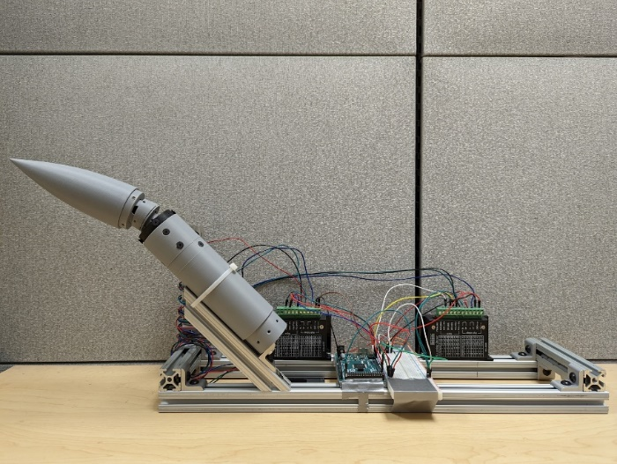
Figure 3: Benchtop Testing Setup
During the testing of our 3D printed model, we were able to achieve the desired motion from our stepper motors which included articulating the nose cone up to 20° and rolling the main body 360° to produce our full range of motion. Additionally, three different skins were made to be used during testing in the wind tunnel.

2.4 Discussion
Although we do not have many results to discuss for our project, there is a lot of planned analysis that has yet to happen that will be outlined here to help condense the future work section. As shown earlier, we were able to achieve the motion we desired from the motors with our 3D printed model. However, due to the tolerances of 3D printing, we were not able to properly validate our rotation angles as the parts were too wobbly to come out within a degree of our desired deflection. Due to this, we were waiting for our machined parts to perform this validation which was not able to occur in time. Upon obtaining our machined model, we will use a dot matrix laid behind the nose cone to determine how accurate we are to the desired angles of pitch and roll. This will also be tracked using a set of cameras during the wind tunnel testing. All of the content related to our validation methods is covered in our validation paper.

2.5 Conclusions
In the end, our project was not able to finish by the due date. However, the project will be continuing into the summer under the AFRL Scholars program which will be discussed further in the future work section. Overall, our project reached moderate levels of completion, but was ultimately not successful. The difficulties of our project entirely stemmed from the size constrictions associated with the model and the rushed design decisions made after out project was revised.
Our team was led to a false sense of security when our 3D printed model successfully completed all the motions we had initially desired. This gave us confidence that our machined model would be able to accomplish the same. However, upon receiving most of our machined parts on Senior Design Day, we realized that the motors would not be able to produce enough torque to allow for the model to rotate. The lack of rotation was confirmed when we assembled the machined parts we had and attempted to run the same test we gave to our 3D printed model.
From this project, many lessons were learned that we will apply to future iteration on this project as well as other projects throughout our life. One of the major takeaways we gained from this project was learning how to deal with failure. Over the course of this entire project, our team experienced constant failures with many of our design decisions and especially during validation. Although it is easy to get caught up in the frustration of failing, we found the best approach to fix our problems is to commit however much time is required to think through where the roots of our failure stem from. Once we identified the source of our problems, we were able to make an estimate of how long a given problem would take to fix.

2.6 Future Work
For the continuation of this project, the design and study of the model will continue assuredly throughout the summer but will also likely be developed for years to come. The main goals that will be targeted for the future of this project will be a redesign of the entire model to enable the use of higher torque motors that require more space. Additionally, there is still work to be done on the control of the stepper motors and dialing in the accuracy. One possibility for the current motors is determining the relationship between both motor velocities in the design to create a close to linear movement of the nose cone to desired angles at desired roll positions. Finally, testing the model in the wind tunnel still needs to occur, but has not happened due to machining difficulties with the model and the additional motor issues that we have run into.
Over the course of the summer immediately following this course, these issues will hopefully be remedied during the AFRL Scholars program. This program will be fully dedicated to this project and will conclude with a conference paper written for the AIAA SciTech Conference the following January.

2.7 References
Dawson, D., Kumar, R., Parker, L., & Taylor, R. (2018). Aerodynamic Characterization of an axisymmetric body with fins at supersonic speeds. AIAA.
Kumar, R., Guha, T. K., & Kumar, R. (2020). Experimental and Numerical Study of Forebody Vortex Interactions on a Generic Axisymmetric Finned Configuration. AIAA.
OMEGA. (n.d.). General Purpose 5 or 10 Vdc Output Pressure Sensors. Retrieved from https://br.omega.com/omegaFiles/pressure/pdf/PX303.pdf
Piao, J., & McDonald, M. (2008). Advanced Driver Assistance Systems from Autonomous to Cooperative Approach. Transport Reviews, 659-684.
Time Critical Conventional Strike from Strategic Standoff. (2009). Defense Technical Information Center.

Appendices

Appendix A: Code of Conduct
Overview
This document provides an overview of the policies and expectations governing Senior Design Group 504. This document may be further updated throughout the semester to provide better clarity on the expectations or on how to handle new procedures required for course completion. Each member of the group was given input on all the following procedures and have agreed upon these terms as recognized by the Statement of Understanding.
Mission Statement
To propel projectile system technologies into the future.
Team Roles
The following roles have been created to align with the goals of our project and the specialization of the group members. Each member decided what tasks they were good at performing with regards to team based engineering assignments and chose their role based on that.
If any required actions arise that fall outside of the required duties listed below, member strengths will be reassessed, and the required actions will be appropriately delegated.
Systems Engineer – Nicholas Samuda
The systems engineer will be responsible for the development of subsystems and integration of these subsystems into the major system. The systems engineer will also regulate or solve all compatibility issues or data translation between systems. The systems engineer is expected to focus on modularity of subsystems as well as the interconnection between them.
Research Engineer – Robert Smith
The research engineer will be responsible for investigating new methods throughout product ideation and will be considered responsible for finding what has previously been accomplished related to the project goal. The research engineer will also be responsible for determining the necessary test to validate potential prototypes and whether the prototypes perform to expectations. The research engineer will also be responsible for making sure that all assignments and required actions such as emails and submitted/sent by their required time.
Field Engineer – Jed Fazler
The field engineer will be responsible for providing support with the experimentation and testing of the project. The field engineer will also be responsible for looking for possible sources of error in measurements made, as well as being responsible for taking the proper safety measures.
Test Engineer – Noah Moffeit
The test engineer will determine how create a process that would best test components or systems to ensure the quality and functionality of the product. The test engineer will work with the research engineer and will oversee functions such as writing test plans, conducting quality assurance, and designing performance tests, and troubleshooting any errors and streamlining the testing procedures.
Communication
All communication within our group will be split between email and texting. All forms of communication are open for change if discussed by the group.
Email
For all official communication and scheduling, email will be used. This includes but is not limited to:
- Communication with mentor/sponsor
- Communication with Dr. McConomy
- All file transfers and updates on task completion
- Notice of absence (see Attendance Policy)
Emails internally within the group will be delivered using the outlook group and shall be sent to the email address seniordesigngroup2021team504@admin.my.fsu.edu. This policy exists such that a timestamped record available will be available to all group members covering the transfer and updates of all important items relating to the project. Every assignment or significant progress update will require being sent and approved by the group before submitting.
Texting
Texting will be used as the method of communication for quick updates. Quicks updates are defined as anything that needs to be communicated but does not have considerable weight governing the outcome of the answer. This could include topics such as asking where we are meeting for the day, or a notice that you will be running a few minutes late to a meetup. With regards to assignments, texting will only be used as an update check asking how someone is doing on their part of the assignment.
Protocol for Delay in Response
All members are expected to respond to email within 24 hours unless outside circumstances prevent them. After 24 hours a reminder will be sent over text. The group may decide to place a strike on the member if no response is received.
Time conflicts and Scheduling
All members of the group are to put their class schedule in the group calendar to determine availability for group meetings. In the occurrence of a conflict, the group must be notified via email 48 hours prior to any meeting involving the project sponsor/advisor. A notification of 24 hours prior to general group meetings is required.
Dress Code
The dress code for our group will vary based on the event. For all scheduled course times (Tues/Thur 3:30-7:45), long pants and a collared or professional shirt are to be worn. All presentations will be business professional, suit jacket, slacks, and button-down shirt. All meetings with the project sponsor/advisor will require long pants, and a collared or professional shirt. Lastly, for general team meetups there is no specific dress code required.
Attendance Policy
Attendance to all meetings and class times is required unless a valid excuse is given. All mandatory and prior discussed meeting times should be attended with punctuality in mind. Emergencies and other properly communicated absences are at the discretion of the other three members. Attendance will be kept at the top of the meeting minutes.
Strike System
If the other three members of the team decide that an absence was not permitted for a specific event, they have the authority to give the absentee a “strike”.
1st Strike – Initial strike. A verbal discussion with the group member at fault to express the reasons for the decision, as well as a chance for the absentee to give a response. A preliminary warning with no direct consequences
2nd Strike – Final strike. A verbal discussion with the absentee at fault to express the reasons for the decision, as well as a chance for the absentee to give a response. After discussion, decide if Dr. McConomy should be contacted and suggest a deduction in participation grade or request that they not be given a grade on the assignment the team member had missed.
How to Amend
For any amendments to the code of conduct, a majority vote must first take place. With three out of the four members voting in favor of any amendment, the code of conduct may be altered to solidify any changes the group may make. An amendment may be proposed and voted upon at any time during the project’s duration.
Amendments
- Group members are no longer required to wear a collared shirt and long pants to general class meetings.
- An email will no longer be sent out before each assignment is due containing an assignment copy. Instead, the assignment will just be uploaded to the group drive and it is up to each group member to make any problems they have with the submission known.

Statement of Understanding
I am aware that the Smart Projectile project policies are available to me through the group files in the shared outlook group. It is my responsibility to familiarize myself with these policies.
In addition, I confirm that I have received, read and understood the previously stated policies.
I agree to conduct myself in accordance with all policies stated in the code of conduct and understand that breaching these standards may result in disciplinary actions decided upon by the rest of the group.

Signatures
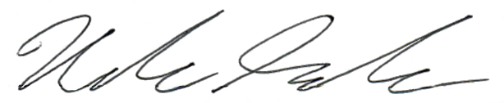
Sep. 7, 2021

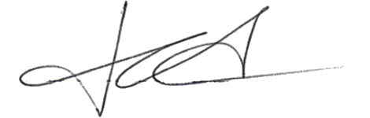
Sep. 7, 2021

Sep. 7, 2021
Sep. 7, 2021

Appendix B: Functional Decomposition

Appendix C: Target Catalog
Table : Targets and Metrics Breakdown
System | Function | Target | Metric
Power | Provides power for components | 60 minutes | Time of Operation
Power | Transmits power to components | $$\sim 5V$$ | Voltage
Sensing | Monitors sensor data | 1 ms | Time
Sensing | Interprets sensor data | 300 ms | Time
Sensing | Transmits sensor data | 9600 Hz | Frequency
Actuation | Controls flow attachment | $$α≤24°$$ | Angle of Attack
Actuation | Controls pitch | CPM $≥$ 3.2 [Unitless] | Coefficient of Pitch Moment (CPM)
Actuation | Controls roll | CRM $≥$ 0.8 [Unitless] | Coefficient of Roll Moment (CRM)
Actuation | Controls yaw | CYM $≥$ 3.2 [Unitless] | Coefficient of Yaw Moment (CYM)
Structure | Maintains integrity | $σ_{s}=3$ (9.6 psig) | Factor of safety
Structure | Protects internal components | IP-65 | Water Proofing standards

Appendix D: Concept Generation and Morphological Chart
Concepts
Brainstorming
- Smart projectile uses an articulating nose cone for manueverability
- Smart projectile uses plasma actuators for flow control
- Smart projectile uses jet actuators on fins that push air over the fins.
- Smart projectile uses jet actuators on fixed nose cone that can change the nose forces.
- Smart projectile uses jet actuators on the fuselage that can change the side forces and provide a push.
- Smart projectile uses modular fuselage that has removable or exchangeable parts.
- Smart projectile uses controllable internal mass that can move throughout the body and change the aerodynamic characteristics.
- Smart projectile uses controllable external mass that can move around the body and change the aerodynamic characteristics.
- Smart projectile uses morphing nose cone that can extend out and retract when needed.
- Smart projectile uses morphing fuselage that can adapt its shape to allow better flow around it.
- Smart projectile uses morphing fins that can widen and thin out depending on the forces they are trying to exert.
- Smart projectile uses toggleable canard that can come out of and retract back into the body for additional maneuverability.
- Smart projectile uses fins with variable skin roughness that can force turbulent transition making the flow harder to separate.
- Smart projectile uses Fuselage with variable slenderness ratio.
- Smart projectile has a nose that can change shape to induce vortices or increase lift.
- Smart projectile uses infrared technology to track.
- Smart projectile uses onboard radar to find target.
- Smart projectile is made like a diaphragm that can measure pressure.
- Smart projectile with eject-able mass that can change the center of mass.
- Smart projectile has lasers that shoot down target.
- Smart projectile that releases gas that can disable other electronics for anti-air.
- Smart projectile ejects small particles that attract water molecules and create clouds to create rougher conditions for other projectiles.
- Smart projectile shoots out rope to attach to target and reel in closer.
- Smart projectile with openable air ducts to reroute flow around it.
- Smart projectile uses wheels for changes in moments.
- Smart projectile shoots out a small missile swarm to hit a larger area.
- Smart projectile shoots a tracking pin at target for pursuit maneuvers.
- Smart projectile uses a rotating nose cone to induce circulation in the flow and generate forces.
- Smart projectile uses piezoelectric flaps to generate instability in flow and keep attachment.
- Smart projectile uses air permeable materials for zero drag and relies purely on thrust.
- Smart projectile uses rotating tail fins to generate lift when flow is detached.
- Smart projectile deploys parachute to slow down when maneuvering.
- Smart Projectile teleports to target.
- Smart projectile is highly magnetic and attracts target missile.
- Smart projectile uses nano-structure that can create and destroy additional fins when needed.
- Smart projectile aborts mission and returns to sender with information on hazardous environment and develops better mission plan.
- Smart projectile is piloted by a shrunken crew allowing them be the brain of the projectile.
- Smart projectile uses AI to adapt to any unforeseen circumstances.
- Smart projectile has an extendo arm that slaps target projectile out of the air.
- Smart projectile attaches to a really fast bird until it gets past hazardous environment
Biomimicry
- Smart projectile with porpoise-like blowhole that knocks target off course
- Smart projectile with bird-like wings to provide control
- Smart projectile with bird like feathers for increased lift
- Smart projectile with bird like beak as nose cone
- Smart projectile with long thin nose needle like a swordfish
- Smart projectile with exoskeleton for extra protection
- Smart projectile with camouflage technology for stealth abilities
- Smart projectile uses shark skin-like surface that induces tiny vortices keeping flow attached.
- Smart projectile with gill-like intake to allow for storage of air and creation of a pressure cavity that can be used to push up flaps that induce vortices.
- Smart projectile with extendable lens covers like a peregrine falcon.
- Smart projectile shaped like fish for aerodynamics.
- Smart projectile with air bladder filled with low density gas that can be vented for rapid altitude adjustments
- Smart projectile with grasshopper-like legs to jump at target.
- Smart projectile with spider-like eyes to provide depth and field of view
- Smart projectile with jellyfish-like tentacles that tangle approaching targets for larger engagement distance
- Smart projectile with dog-like nose that can “smell" exhaust for tracking
Morphological
- A projectile that controls flow using plasma and uses an articulating nose cone for mechanical control.
- A projectile that uses microjets for flow control and uses an articulating nose cone for mechanical control.
- A projectile that uses piezoelectric flaps for flow control and uses an articulating nose cone for mechanical control.
- A projectile that uses spark jets for flow control and uses an articulating nose cone for mechanical control.
- A projectile that controls flow using plasma and uses deflecting flaps for mechanical control.
- A projectile that controls flow using microjets and uses deflecting flaps for mechanical control.
- A projectile that controls flow using piezoelectric flaps and uses deflecting flaps for mechanical control.
- A projectile that controls flow using spark jets and uses deflecting flaps for mechanical control.
- A projectile that controls flow using plasma and uses side thrusters for mechanical control.
- A projectile that controls flow using plasma and uses side thrusters for mechanical control.
- A projectile that controls flow using microjets and uses side thrusters for mechanical control.
- A projectile that controls flow using piezoelectric flaps and uses side thrusters for mechanical control.
- A projectile that controls flow using spark jets and uses side thrusters for mechanical control.
- A projectile that controls flow using plasma and uses internal mass for mechanical control.
- A projectile that controls flow using microjets and uses internal mass for mechanical control.
- A projectile that controls flow using spark jets and uses internal mass for mechanical control.
- A projectile that controls flow using plasma and uses drag panels for mechanical control.
- A projectile that controls flow using microjets and uses drag panels for mechanical control.
- A projectile that controls flow using piezoelectric flaps and uses drag panels for mechanical control.
- A projectile that controls flow using spark jets and uses drag panels for mechanical control.
- A projectile that controls flow using a pulsating jet and uses an articulating nose cone for mechanical control.
- A projectile that controls flow using a pulsating jet and uses deflecting flaps for mechanical control.
- A projectile that controls flow using a pulsating jet and uses side thrusters for mechanical control.
- A projectile that controls flow using a pulsating jet and uses drag panels for mechanical control.
- A projectile that uses a pulsating jet to control flow and an internal mass for mechanical control.
- A projectile that uses gill intakes to control flow and an articulating nose cone for mechanical control
- A projectile that uses gill intakes to control flow and deflecting flaps for mechanical control.
- A projectile that uses gill intakes to control flow and side thrusters for mechanical control.
- A projectile that uses gill intakes to control flow and an internal mass for mechanical control.
- A projectile that uses gill intakes to control flow and drag panels for mechanical control.
- A projectile that uses combustion to control flow and an articulating nose cone for mechanical control.
- A projectile that uses combustion to control flow and deflecting flaps for mechanical control.
- A projectile that uses combustion to control flow and side thrusters for mechanical control.
- A projectile that uses combustion to control flow and internal mass for mechanical control.
- A projectile that uses combustion to control flow and drag panels for mechanical control.
- A projectile that uses vortex generators to control flow and articulating nose cone for mechanical control.
- A projectile that uses vortex generators to control flow and deflecting flaps for mechanical control.
- A projectile that uses vortex generators to control flow and side thrusters for mechanical control.
- A projectile that uses vortex generators to control flow and an internal mass for mechanical control.
- A projectile that uses vortex generators to control flow and drag panels for mechanical control.
- A projectile that uses active dimples for flow control and an articulating nose cone for mechanical control.
- A projectile that uses active dimples for flow control and deflecting flaps for mechanical control.
- A projectile that uses active dimples for flow control and side thrusters for mechanical control.
- A projectile that uses active dimples for flow control and an internal mass for mechanical control.
- A projectile that uses active dimples for flow control and drag panels for mechanical control.
Morphological Chart
Table : Morphological Chart
Flow Control | Mechanical Control
Plasma | Articulating Nose Cone
Micro Jets | Deflecting Flaps
Piezoelectric Flaps | Side Thrusters
Spark jets | Internal Mass
Pulsating Jet | Drag Panels
Gills
Combustion
Vortex Generators
Active Dimples

Medium Fidelity Concepts
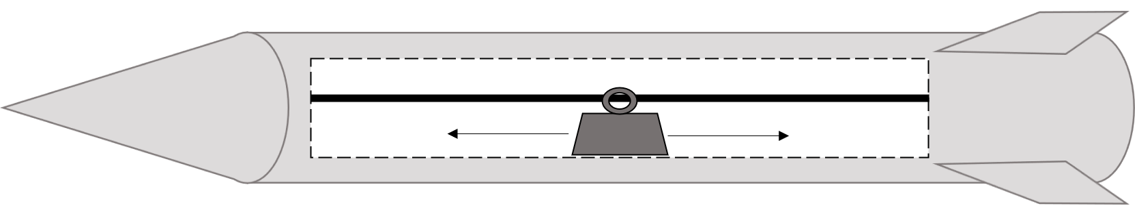
Figure 4: Medium Fidelity Concept #1: Movable internal mass
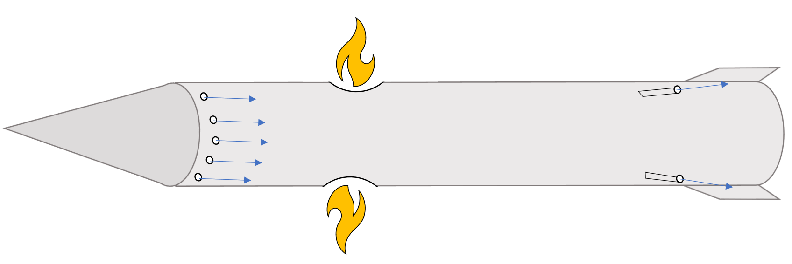
Figure 5: Medium Fidelity Concept #2: Side Thrusters with Pulsating Jets
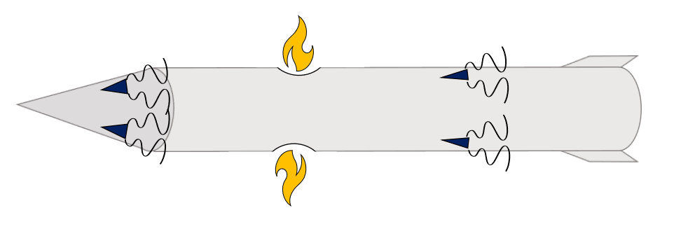
Figure 6: Medium Fidelity Concept #3: Side thrusters with vortex generators

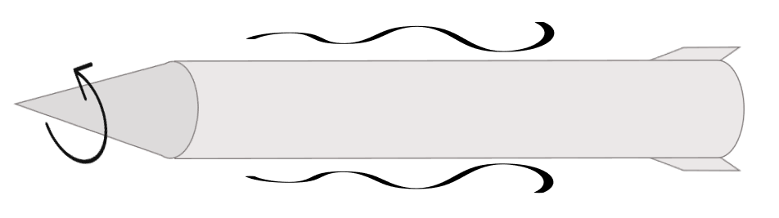
Figure 7: Medium Fidelity Concept #4: Rotating Nose Cone
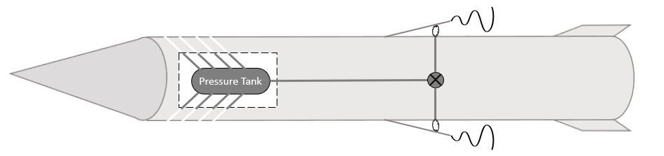
Figure 8: Medium Fidelity Concept #5: Gill Intakes

High Fidelity Concepts
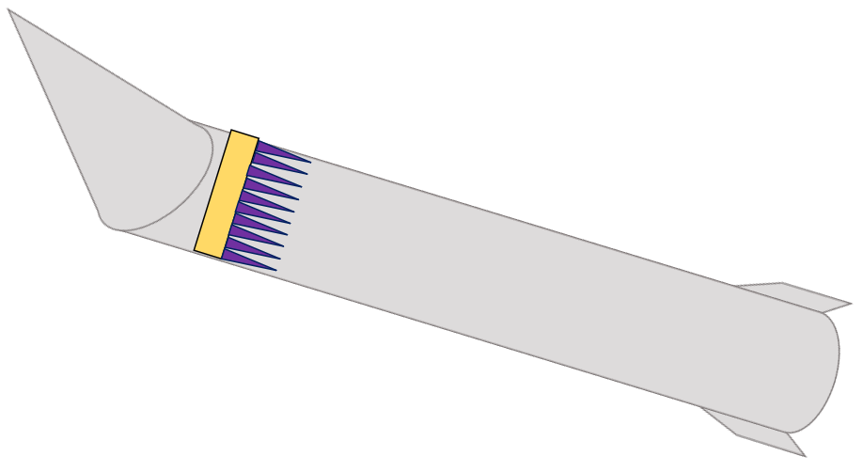
Figure 9: High Fidelity Concept #1: Articulating nose cone with plasma actuators

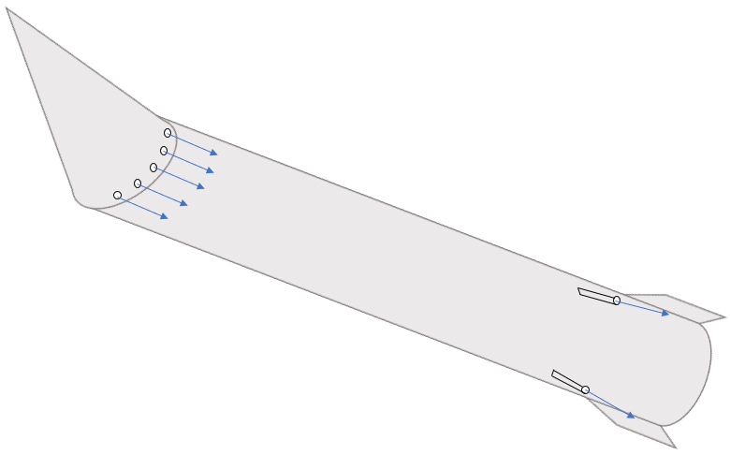
Figure 10: High Fidelity Concept #2 - Articulating nose cone with microjet actuators
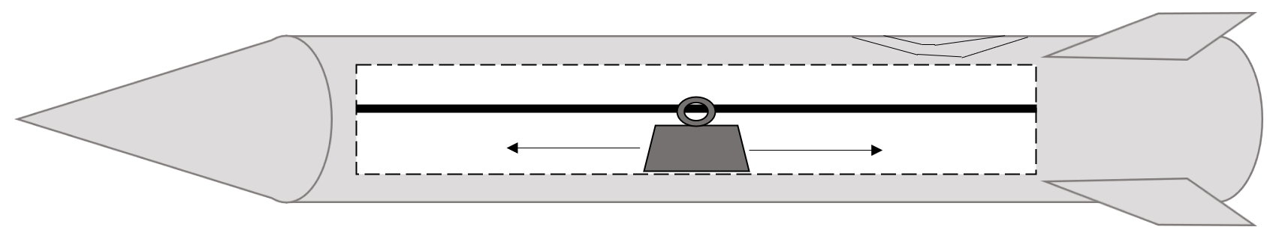
Figure 11: High Fidelity Concept #3: Movable internal mass with a sparkjet actuator

Appendix D: Binary Pairwise Comparison
Table 11: Binary Pairwise Comparison
Customer Needs | Projectile controls flow seperation | Projectile model is capable of testing at Mach 4 | Projectile uses an Axisymmetric Body | Projectile can rapidly adapt to flow conditions | Projectile can react automatically | Projectile can adapt to high pitching angles | Sum
Projectile controls flow seperation | - | 1 | 1 | 1 | 1 | 1 | 5
Projectile model is capable of testing at Mach 4 | 0 | - | 1 | 0 | 0 | 0 | 1
Projectile uses an Axisymmetric Body | 0 | 0 | - | 0 | 0 | 0 | 0
Projectile can rapidly adapt to flow conditions | 0 | 1 | 1 | - | 0 | 0 | 2
Projectile can react automatically | 0 | 1 | 1 | 1 | - | 1 | 4
Projectile can adapt to high pitching angles | 0 | 1 | 1 | 1 | 0 | - | 3
Sum | 0 | 4 | 5 | 3 | 1 | 2 | n-1 = 5

Appendix E: House of Quality
Table 12: House of Quality
 |  | Engineering Characteristics
Improvement Direction |  | ↑ | ↓ | ↓ | ↓ | ↑ | ↑ | ↑ | ↑
Units |  | Time (mins) | Voltage (V) | Time (ms) | Time (s) | Frequencey (Hz) | Angle of Attack | Unitless Coefficients | Water Proofing Standards
Customer Requirements | Importance Weight Factor | Provides Power for Components | Transmits Power to Components | Monitors Sensor Data | Interprets Sensor Data | Transmits Sensor Data | Controls Flow Attachment | Controls Aerodynamic Moments | Protects Internal Components
Projectile controls flow separation | 5 | 3 | 9 | 1 | 1 | 1 | 9 | 3
Projectile model is capable of testing at Mach 4 | 1 |  |  |  |  |  | 1 |  | 9
Projectile uses an Axisymmetric Body | 0 |  | 1 |  |  |  | 1 | 3 | 3
Projectile can rapidly adapt to flow conditions | 2 | 3 | 3 | 3 | 9 | 3 | 1 | 1 | 1
Projectile can react automatically | 4 | 3 | 1 | 9 | 9 | 3 | 3
Projectile can adapt to high pitching angles | 3 | 1 | 1 | 1 | 3 |  | 3 | 2
Raw Score (338) |  | 36 | 58 | 50 | 68 | 23 | 69 | 23 | 11
Relative Weight |  | 10.65 | 17.16 | 14.79 | 20.12 | 6.80 | 20.41 | 6.80 | 3.25
Rank Order |  | 5 | 3 | 4 | 2 | 6 | 1 | 6 | 8

Appendix F: Pugh Charts
Table 13: Initial Pugh Chart
Pugh Chart
Function |  | Concept
 |  | #7 | #80 | #95 | #28 | #49 | #58 | #59 | #73
Controls flow separation | Datum (Basic Body with fin deflection) | - | + | S | S | - | + | + | +
Able to be tested at Mach 4 |  | S | S | S | S | - | S | S | S
Axisymmetric Body |  | S | S | - | S | S | S | S | S
Adapts to flow conditions |  | - | + | + | S | - | + | + | +
Reacts automatically |  | S | S | S | S | + | + | + | +
Adapts to high pitch angles |  | + | - | S | - | S | + | + | +
 | Plus (+) | 1 | 2 | 1 | 0 | 1 | 4 | 4 | 4
 | Satisfactory (S) | 3 | 3 | 4 | 5 | 2 | 2 | 2 | 2
 | Minus (-) | 2 | 1 | 1 | 1 | 3 | 0 | 0 | 0

Table 14: Second Pugh Chart
Pugh Chart
Function |  | Concept
 |  | #7 | #80 | #49 | #58 | #59 | #73
Controls flow separation | Datum (Concept #95) | S | + | - | + | + | +
Able to be tested at Mach 4 |  | S | S | - | S | S | S
Axisymmetric Body |  | + | + | + | + | + | +
Adapts to flow conditions |  | - | - | S | - | + | -
Reacts automatically |  | + | S | + | + | + | +
Adapts to high pitch angles |  | + | + | + | + | + | +
 | Plus (+) | 3 | 3 | 3 | 4 | 5 | 4
 | Satisfactory (S) | 2 | 2 | 1 | 1 | 1 | 1
 | Minus (-) | 1 | 1 | 2 | 1 | 0 | 1

Table 15: Final Pugh Chart
Pugh Chart
 |  | Concept
Function |  | #7 | #58 | #59 | #73
Controls flow separation | Datum (Concept #80) | - | - | + | +
Able to be tested at Mach 4 |  | + | S | S | S
Axisymmetric Body |  | S | S | S | S
Adapts to flow conditions |  | S | - | + | -
Reacts automatically |  | + | + | + | +
Adapts to high pitch angles |  | S | - | + | +
 | Plus (+) | 2 | 1 | 4 | 3
 | Satisfactory (S) | 3 | 2 | 2 | 2
 | Minus (-) | 1 | 3 | 0 | 1

Appendix G: Analytical Hierarchy Process
Table 16: Analytical Hierarchy Chart
Analytical Hierarchy Process
Criteria | Provides Power for Components | Transmits Power to Components | Monitors Sensor Data | Interprets Sensor Data | Transmits Sensor Data | Controls Flow Attachment | Controls Aerodynamic Moments | Protects Internal Components
Provides Power for Components | 1.000 | 1.000 | 0.333 | 0.333 | 0.333 | 0.200 | 0.200 | 0.333
Transmits Power to Components | 1.000 | 1.000 | 2.000 | 1.000 | 3.000 | 0.333 | 0.333 | 1.000
Monitors Sensor Data | 3.000 | 0.500 | 1.000 | 0.333 | 3.000 | 1.000 | 0.333 | 0.333
Interprets Sensor Data | 3.000 | 1.000 | 3.000 | 1.000 | 3.000 | 1.000 | 1.000 | 1.000
Transmits Sensor Data | 3.000 | 0.333 | 0.333 | 0.333 | 1.000 | 1.000 | 0.333 | 1.000
Controls Flow Attachment | 5.000 | 3.000 | 1.000 | 1.000 | 1.000 | 1.000 | 0.333 | 1.000
Controls Aerodynamic Moments | 5.000 | 3.000 | 3.000 | 1.000 | 3.000 | 3.000 | 1.000 | 2.000
Protects Internal Components | 3.000 | 1.000 | 3.000 | 1.000 | 1.000 | 1.000 | 0.500 | 1.000
SUM | 24.000 | 10.833 | 13.667 | 6.000 | 15.333 | 8.533 | 4.033 | 7.667

Table 17: Normalized Analytical Hierarchy Chart
Normalized Criteria Comparison Matrix [NormC]
Criteria | Provides Power for Components | Transmits Power to Components | Monitors Sensor Data | Interprets Sensor Data | Transmits Sensor Data | Controls Flow Attachment | Controls Aerodynamic Moments | Protects Internal Components | Criteria Weight {W}
Provides Power for Components | 0.042 | 0.092 | 0.024 | 0.056 | 0.022 | 0.023 | 0.050 | 0.043 | 0.044
Transmits Power to Components | 0.042 | 0.092 | 0.146 | 0.167 | 0.196 | 0.039 | 0.083 | 0.130 | 0.112
Monitors Sensor Data | 0.125 | 0.046 | 0.073 | 0.056 | 0.196 | 0.117 | 0.083 | 0.043 | 0.092
Interprets Sensor Data | 0.125 | 0.092 | 0.220 | 0.167 | 0.196 | 0.117 | 0.248 | 0.130 | 0.162
Transmits Sensor Data | 0.125 | 0.031 | 0.024 | 0.056 | 0.065 | 0.117 | 0.083 | 0.130 | 0.079
Controls Flow Attachment | 0.208 | 0.277 | 0.073 | 0.167 | 0.065 | 0.117 | 0.083 | 0.130 | 0.140
Controls Aerodynamic Moments | 0.208 | 0.277 | 0.220 | 0.167 | 0.196 | 0.352 | 0.248 | 0.261 | 0.241
Protects Internal Components | 0.125 | 0.092 | 0.220 | 0.167 | 0.065 | 0.117 | 0.124 | 0.130 | 0.130
SUM | 1.000 | 1.000 | 1.000 | 1.000 | 1.000 | 1.000 | 1.000 | 1.000 | 1.000

Table 18: Consistency Check
Consistency Check
{Ws}={C}{W} | {W} |  | Cons={Ws}./{W}
Weighted Sum Vector | Criteria Weights |  | Consistency Vector
0.386 | 0.044 |  | 8.779
0.996 | 0.112 |  | 8.906
0.835 | 0.092 |  | 9.038
1.431 | 0.162 |  | 8.839
0.683 | 0.079 |  | 8.662
1.239 | 0.140 |  | 8.847
2.152 | 0.241 |  | 8.934
1.152 | 0.130 |  | 8.861
Average Consistency (λ): |  | 8.858
Consistency Index (CI): |  | 0.123
Consistency Ratio (CR): |  | 0.088

Table 19: AHP Provides Power for Components
Provides Power for Components Comparison [C]
 |  | Design #7: |  | Design #59: |  | Design #73:
Design #7: |  | 1.000 |  | 3.000 |  | 7.000
Design #59: |  | 0.333 |  | 1.000 |  | 3.000
Design #73: |  | 0.143 |  | 0.333 |  | 1.000
SUM: |  | 1.476 |  | 4.333 |  | 11.000
Normalized Provides Power for Components Comparison [NormC]
 |  | Design #7: | Design #59: |  | Design #73: | D.A.P {Pi}
Design #7: |  | 0.677 | 0.692 |  | 0.636 | 0.669
Design #59: |  | 0.226 | 0.231 |  | 0.273 | 0.243
Design #73: |  | 0.097 | 0.077 |  | 0.091 | 0.088
SUM: |  | 1.000 | 1.000 |  | 1.000 | 1.000
Consistency Check
{Ws}={C}{Pi} | {Pi} | Cons={Ws}./{Pi}
Weighted Sum Vector | Criteria Weights | Consistency Vector
2.015414693 | 0.669 | 3.013943551
0.730606311 | 0.243 | 3.005361377
0.26476391 | 0.088 | 3.001786222

Table 20: Final Rating Matrix
Final Rating Comparison
Selection Criteria | Design #7: | Design #59: | Design #73:
Provides Power for Components | 0.669 | 0.243 | 0.088
Transmits Power to Components | 0.633 | 0.106 | 0.260
Monitors Sensor Data | 0.143 | 0.429 | 0.429
Interprets Sensor Data | 0.143 | 0.429 | 0.429
Transmits Sensor Data | 0.200 | 0.600 | 0.200
Controls Flow Attachment | 0.106 | 0.633 | 0.260
Controls Aerodynamic Moments | 0.225 | 0.454 | 0.321
Protects Internal Components | 0.429 | 0.143 | 0.429

Table 21: Criteria Weights
Criteria Weights
Provides Power for Components | 0.044
Transmits Power to Components | 0.112
Monitors Sensor Data | 0.092
Interprets Sensor Data | 0.162
Transmits Sensor Data | 0.079
Controls Flow Attachment | 0.140
Controls Aerodynamic Moments | 0.241
Protects Internal Components | 0.130

Appendix H: Operation Manual

Overview

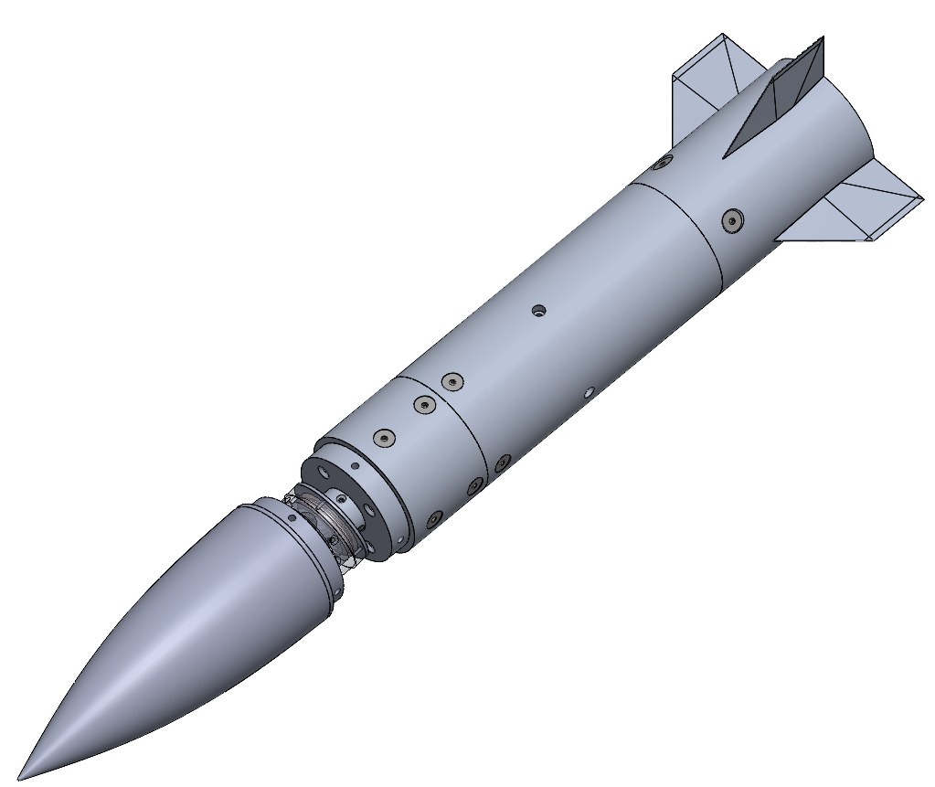

The Florida Center for Advanced Aero-Propulsion (FCAAP) plans to implement a new flight control method for analysis. Current missile technologies employ fins and canards that are used for controlling the maneuverability of the missile. With the removal of fins, more space would be made available within the missile, allowing for increased storage of crucial components such as fuel. Thus, making modifications to the nose the optimal choice for enhancing the missile control. Our goal is to create a rotating nose cone model that allows for control such that fins would not be needed. The model will be tested in a low-speed wind tunnel. To control the rotation of the nose, internal motors are connected to a controller located outside the tunnel will be used that will alter the nose mechanism to the appropriate angle.

Project Objective
The objective of this project is to design a method for articulation of a nose cone for use in a wind tunnel.

Key Goals
There are two main goals aimed to be achieved after completion of this project.
- The nose cone must reach a range of ±20 degrees of deflection after the linear motion is accounted for
- The interface between the nose cone and the body must be accounted for in order to not disturb the flow characteristics downstream

Components/Assembly
Listed below are the steps to assemble the nose articulation mechanism and a detailed description of each component and the role they play in the assembly. Larger scale CAD drawings can be found in Appendix A.
- Back Body
The back body is placed on the rear of the model, covering the middle outer body. The back body is meant to replace the back body with fins during testing. Using this component allows for data acquisition of conditions that are unaffected by fins. The back body is made of 6061 Aluminum.
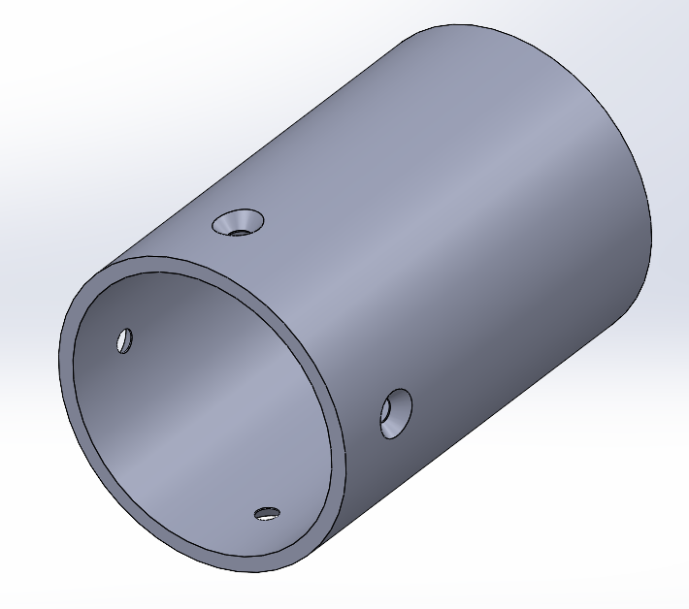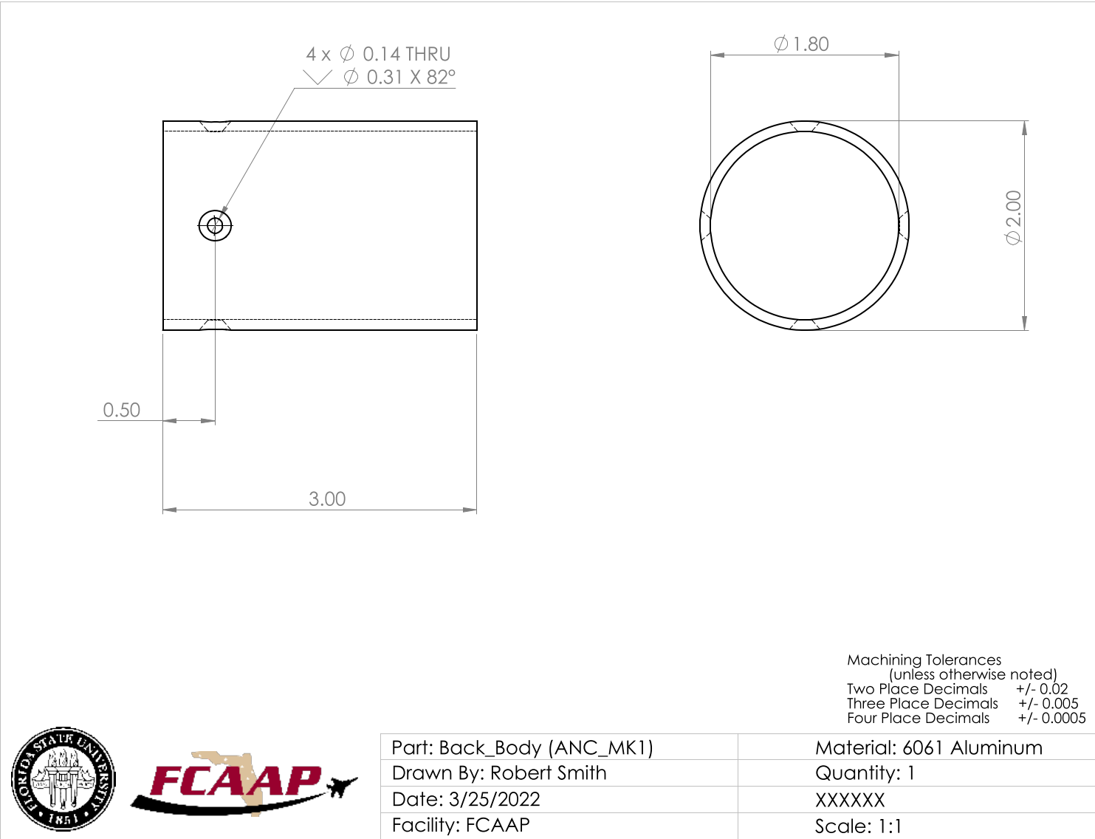
- Back Body with Fins
The Back Body with Fins is placed in the same location as the back body. This component is used during tests to simulate the effects of fins on the articulating nose cone model. The back body with fins is made from 6061 Aluminum.

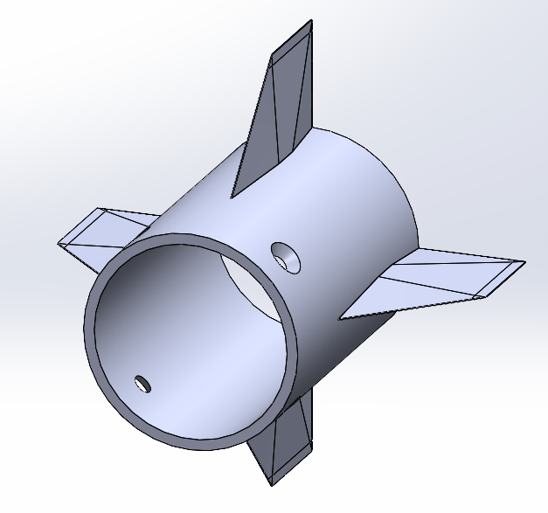
- Back Motor Mount
The back motor mount is used to mount the rear rotation motor as well as one of the cross-roller bearings. The back motor mount is installed inside of the middle outer body using three 6-32 screws. The back motor mount is made of 6061 Aluminum.
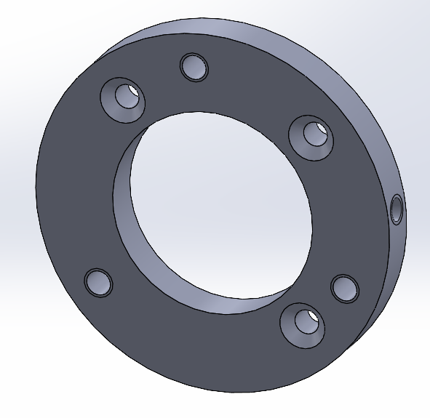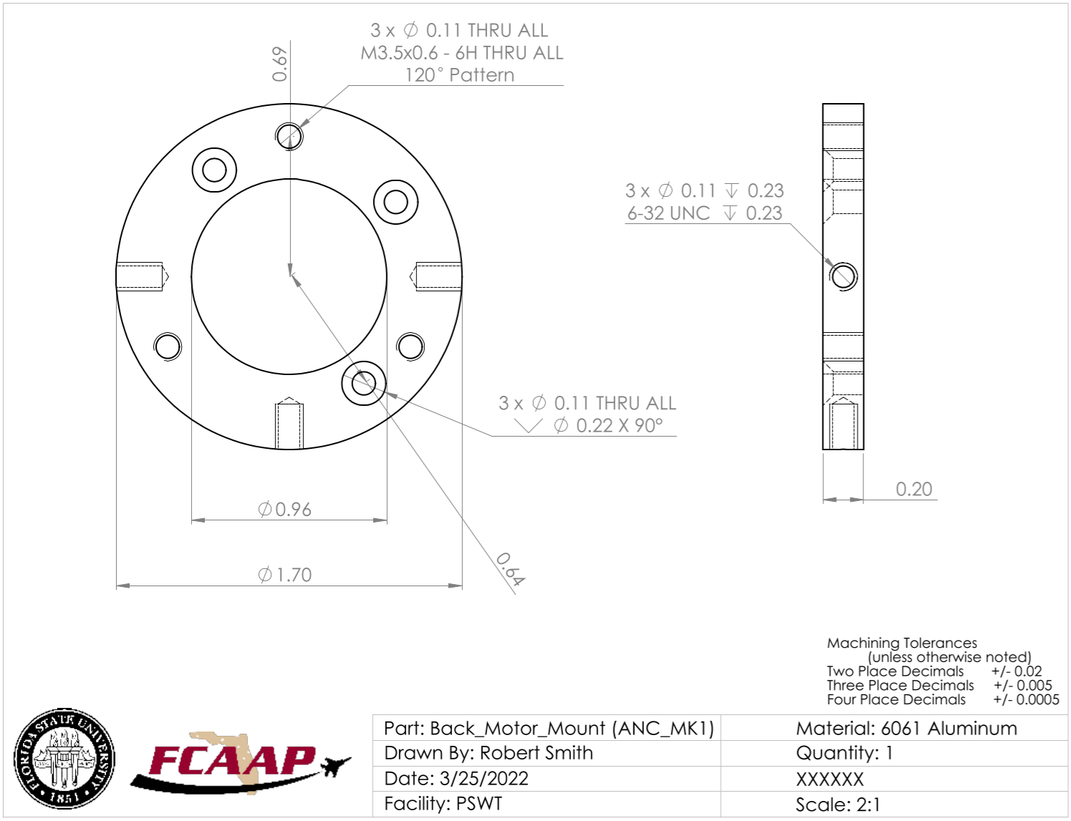
- Bending Sleeves
The bending sleeves are flexible cylindrical pieces that are placed over the entire deflection mechanism. Three sleeves have been produced, a single filament 3D print, a multi-filament 3D print, and a silicon-resin cast sleeve.

- Bronze Inserts
The bronze inserts are placed on both sides of the rear deflecting surface’s flange. The inserts reduce the friction experienced between the contact surfaces and the collar. Both inserts are made from 932 bearing bronze.
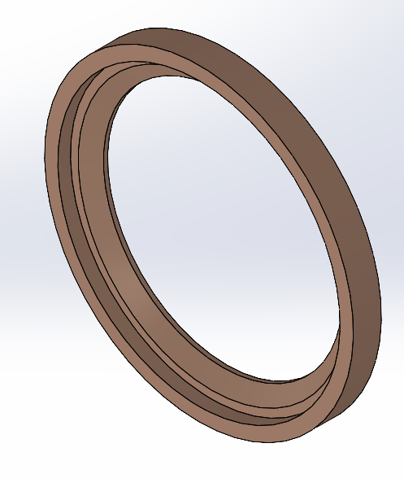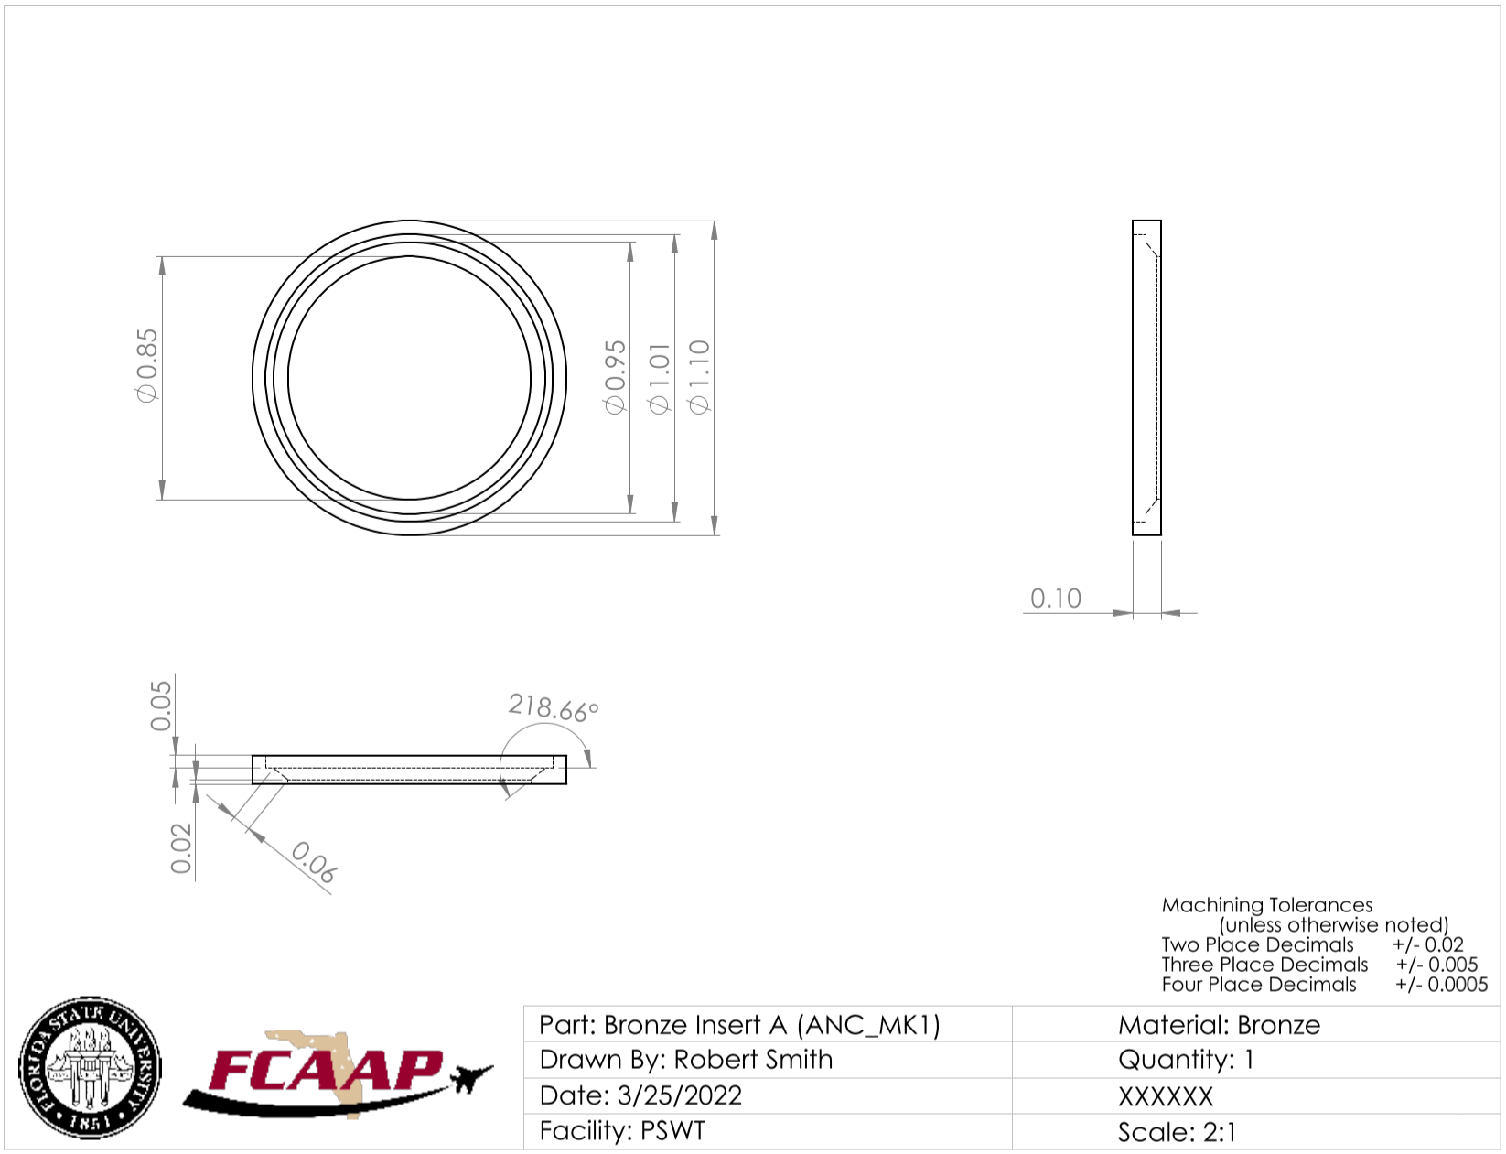
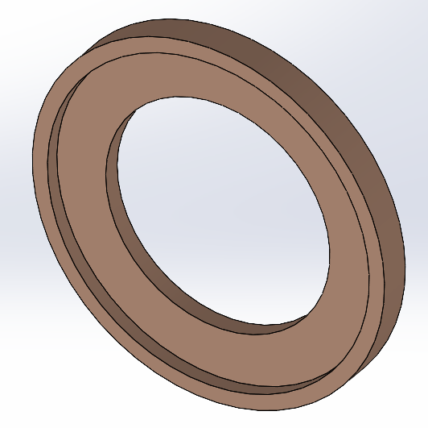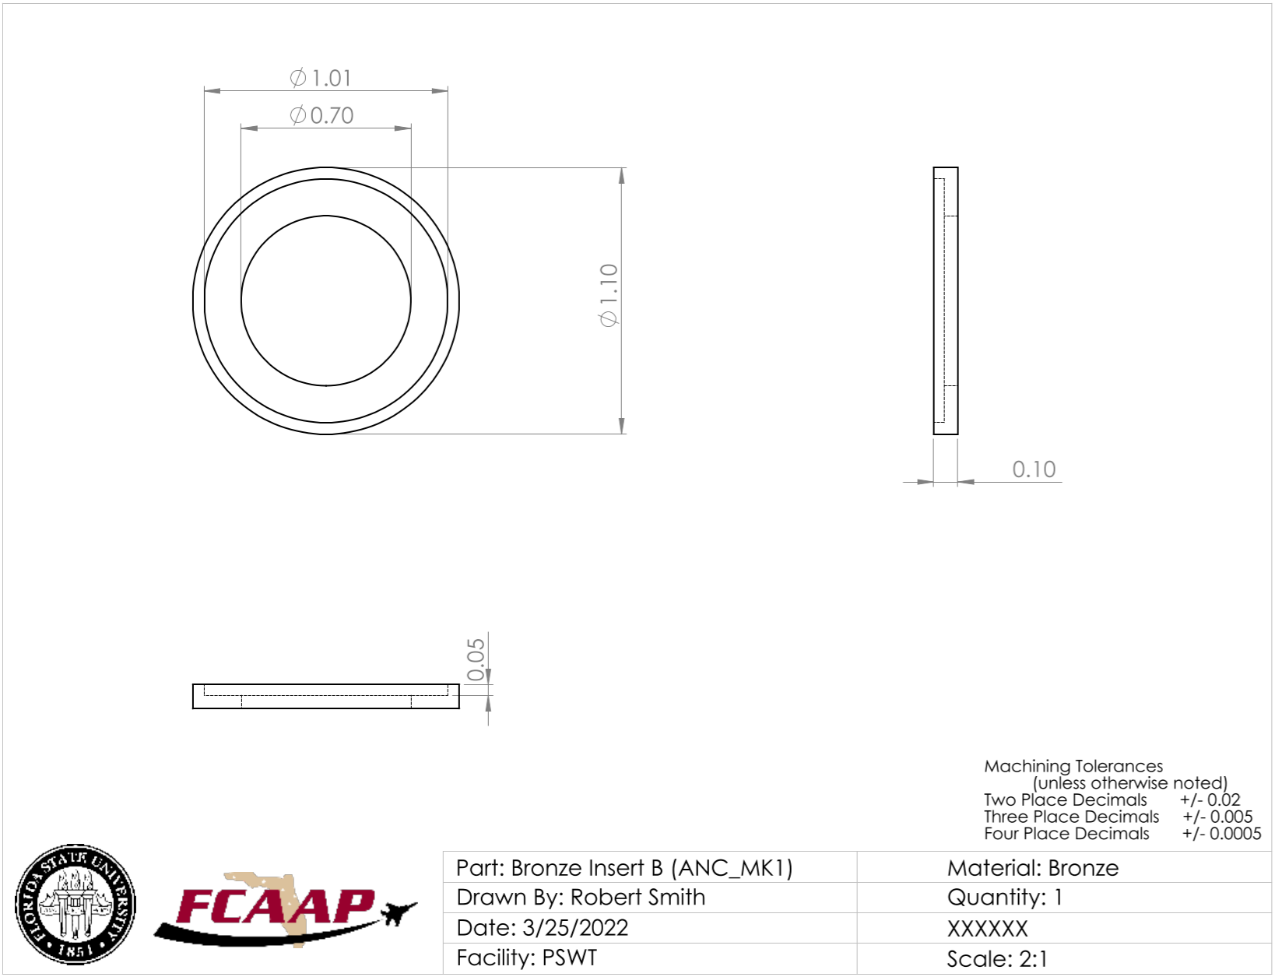

- Collar
The collar is placed over the two deflecting surfaces to keep both contact surfaces in place. The collar slides over and is installed into the front deflecting surface. With both bronze inserts in place, the collar cap is then placed over the opposite end and fastened down. The collar is made from 6061 Aluminum.

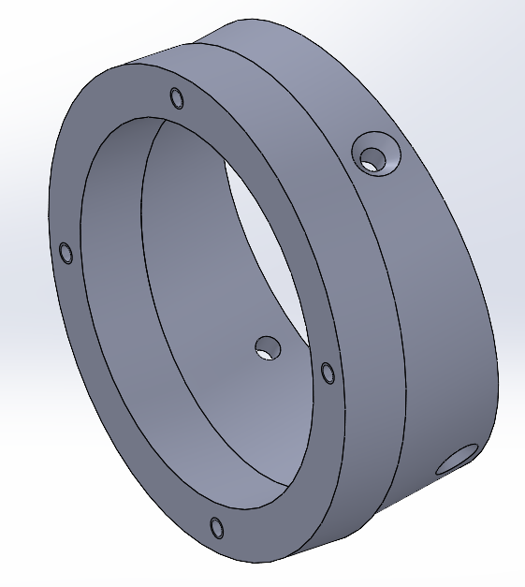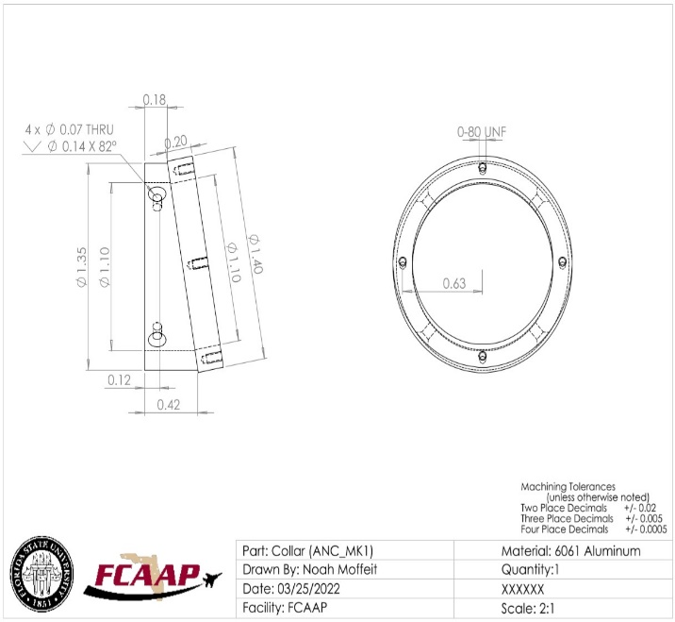
- Collar Cap
The collar cap is placed over the collar and brass inserts. This component keeps the brass inserts in place and provides a tight hold on the contact surfaces.
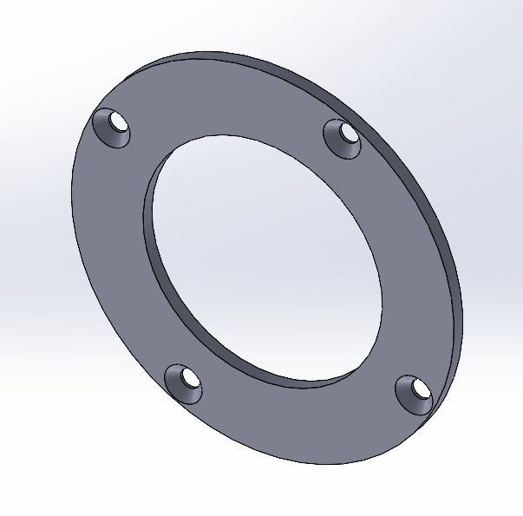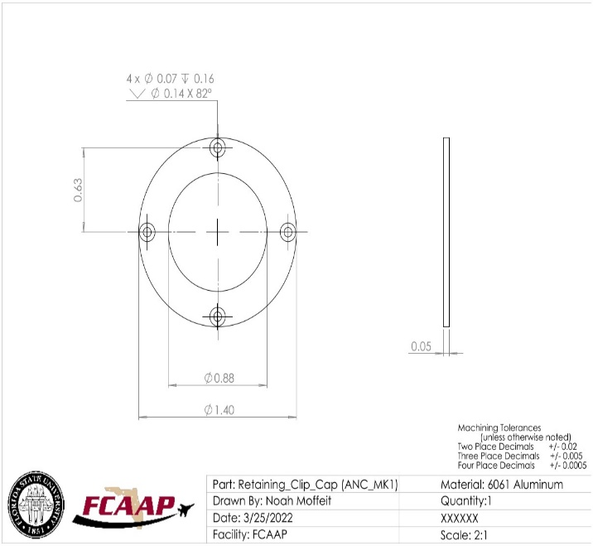
- Face-Mounted Cross Roller Bearings
Two face-mounted cross roller bearings are used in the assembly. One of which is fastened onto the back motor mount and the mounting hub. This allows the frontal section and the middle section of the outer body to rotate freely and maintain axial position. The second bearing is installed between the nose and the sleeve cuff, allowing the nose to rotate without torquing the bending sleeve.
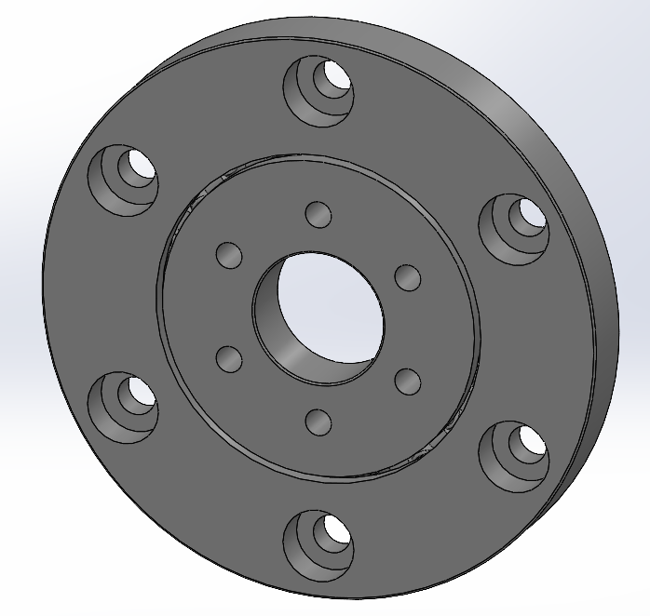

- Frontal Deflecting Surface
The frontal deflecting surface is installed on the cross roller bearing mounted on the nose. This component provides a 10-degree deflected surface that is used to pitch the nose cone. The frontal deflecting surface is rotated using the rotation pin driven by the short shaft motor. This component is made from 6061 Aluminum.
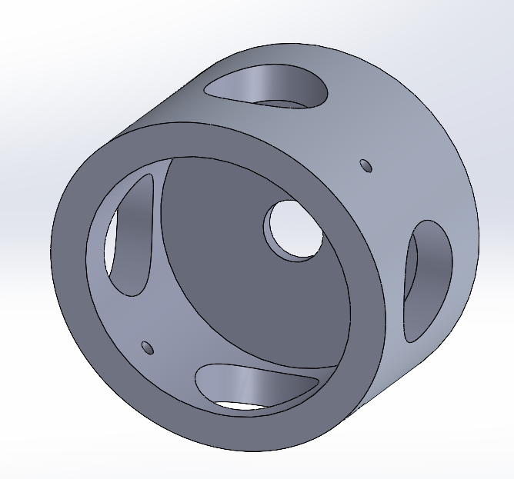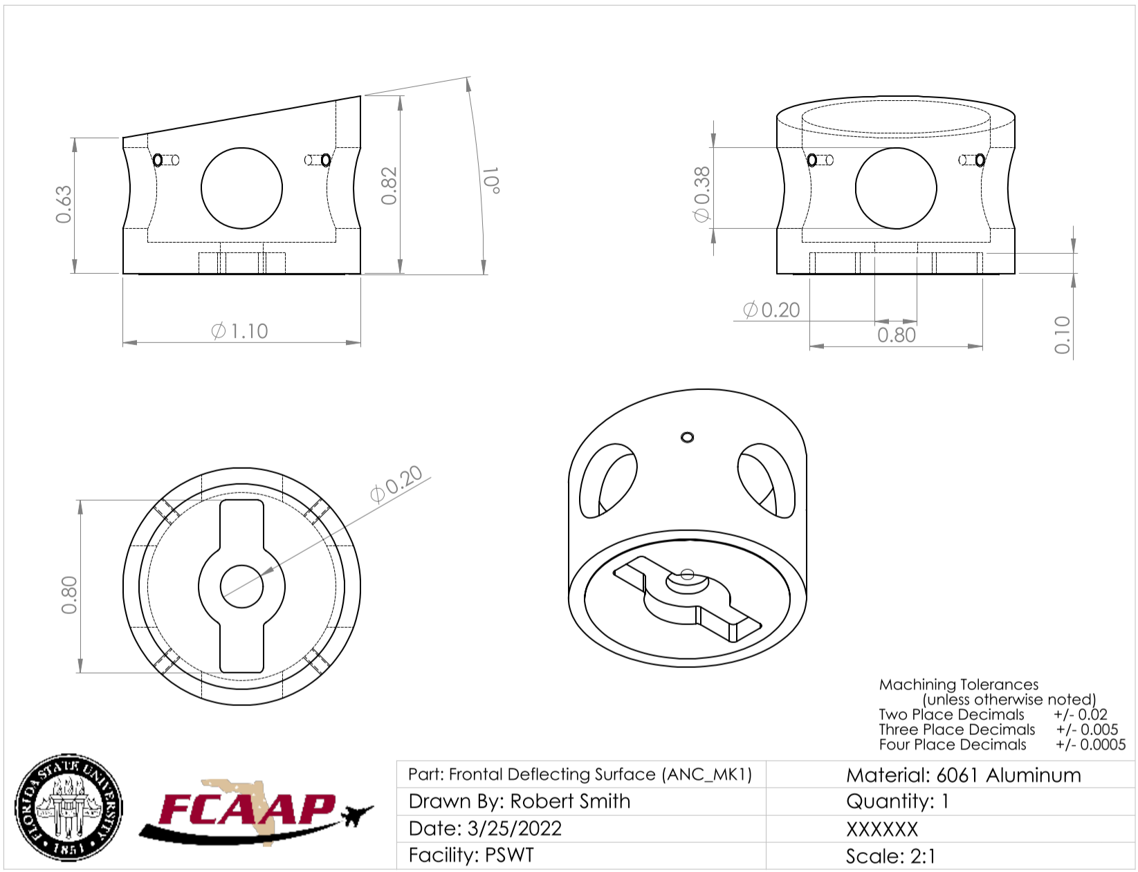
- Frontal Motor Mount
The frontal motor mount holds the short shaft motor that is used to deflect the nose. This component is installed inside of the frontal outer body on the non-chamfered section. The frontal motor mount also holds the frontal deflecting surface that is installed on the protruding cylinder.
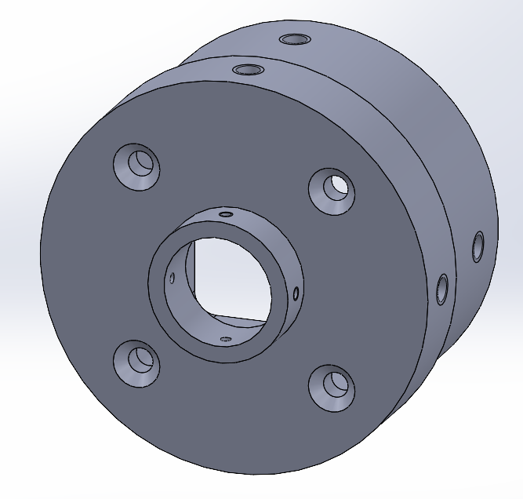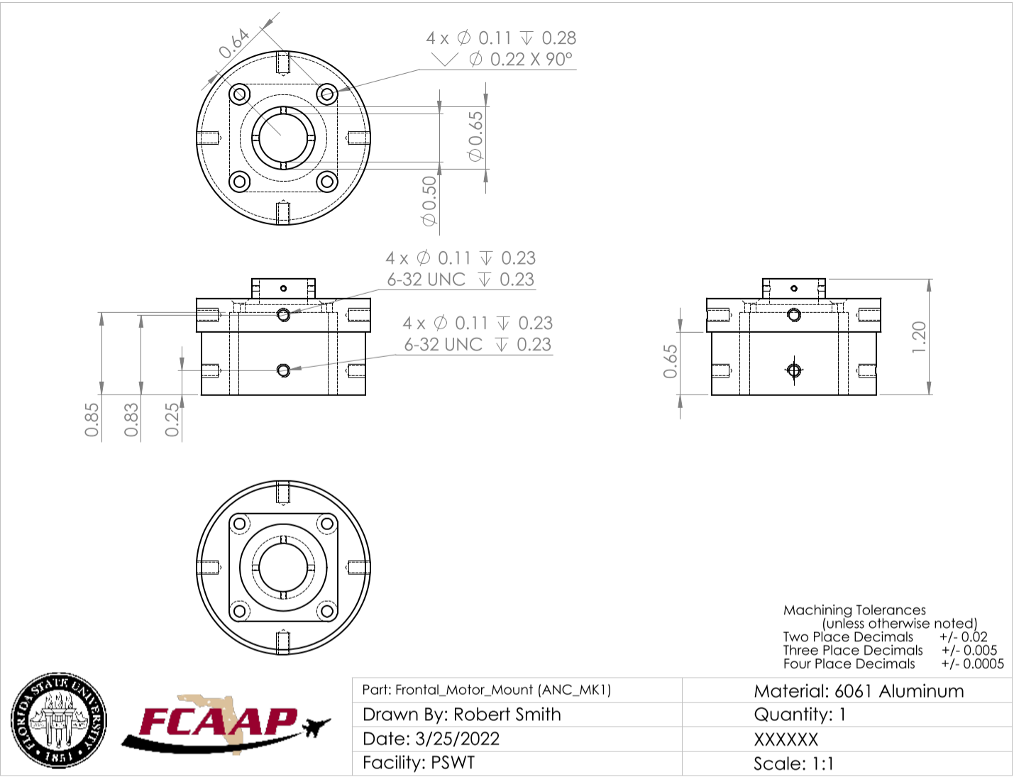
- Frontal Outer Body
The frontal outer body holds the frontal motor mount and the mounting hub. This component is allowed to rotate freely of the middle outer body. The frontal outer body has a chamfer on its rear side allowing for wires to pass freely.
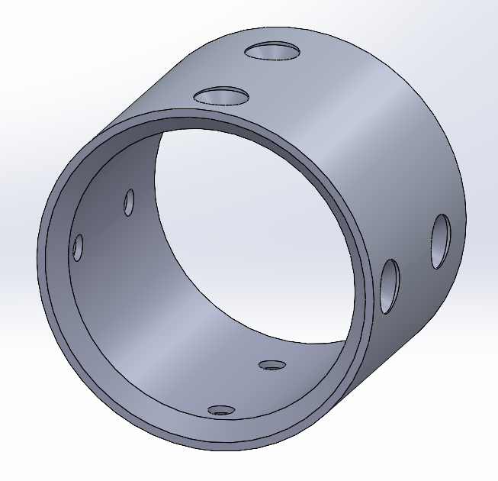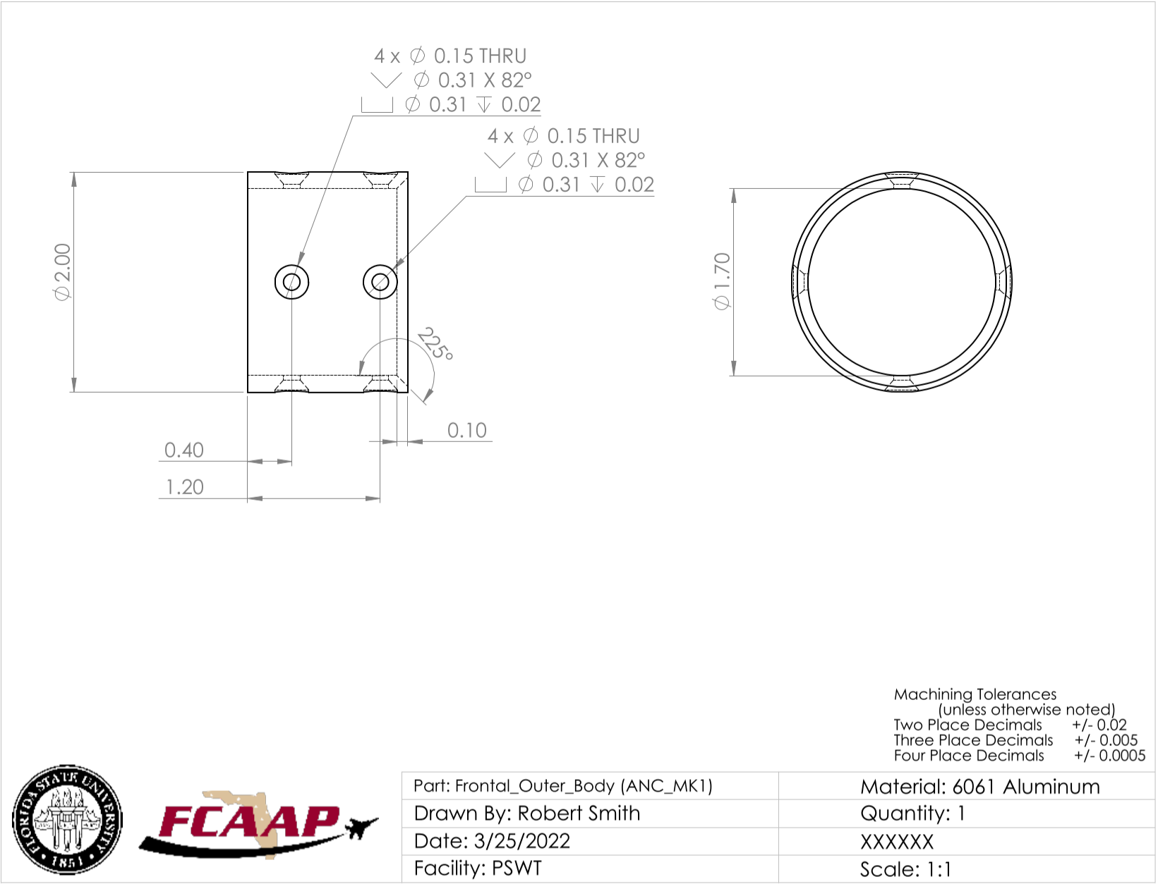
- Middle Outer Body
The middle outer body contains the long shaft motor, back motor mount, and a cross roller bearing. This component is used to hold the rolling mechanism of the assembly as well as mounts on the force balance to acquire force measurements during testing. The middle outer body is made from Aluminum 6061.
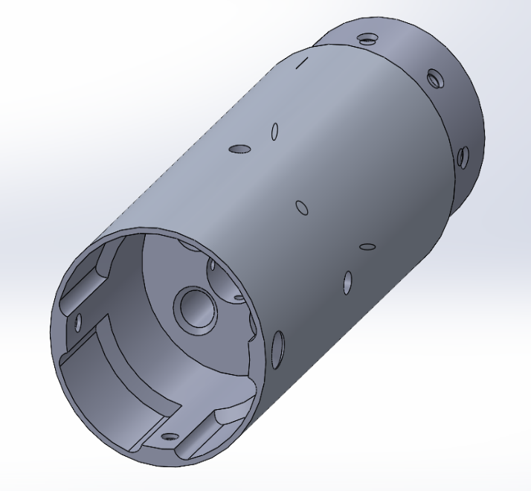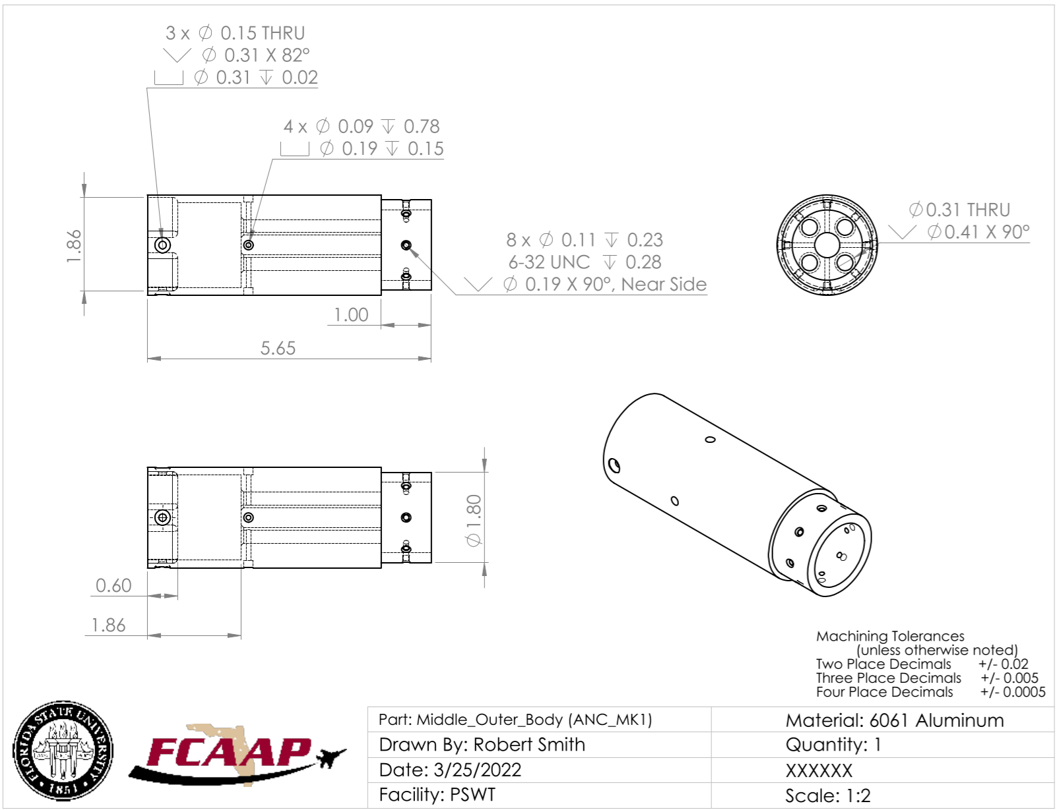
- Motors
Two NEMA 11 DC motors are used to deflect and rotate the nose. The long-shaft motor is installed on the back motor mount and placed inside of the middle outer body. The shaft is placed inside of the mounting hub and fastened with a set screw, allowing for rotation of the frontal outer body. The short-shaft motor is installed inside of the frontal motor mount that is placed inside of the frontal outer body. This component is used to deflect the nose through the use of the universal joint that is placed on the shaft where a 1/16” diameter spring pin is used to hold the two components in place.
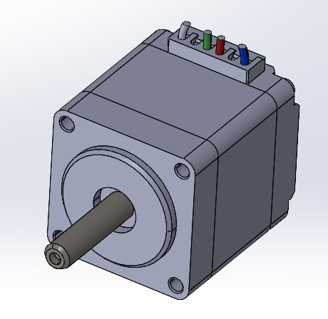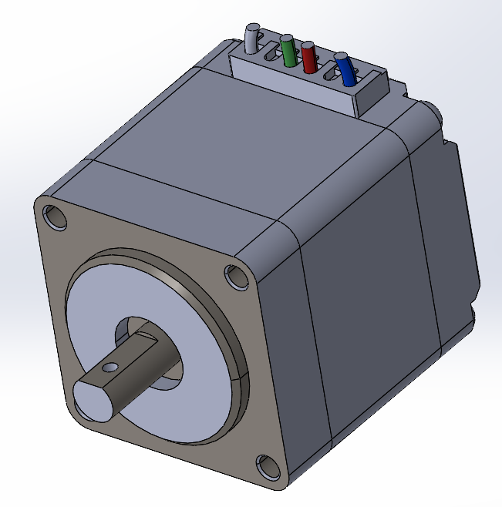
- Mounting Hub
The mounting hub is first installed on the cross roller bearing placed in the rear of the assembly. Then a set screw is placed in the back of the component to hold the shaft of the long-shaft motor in place. Lastly, the mounting hub is placed inside of the frontal outer body and fastened down.
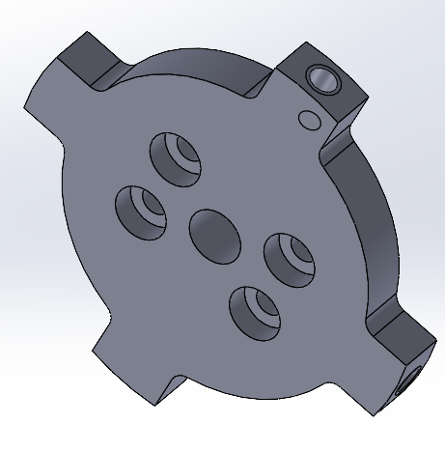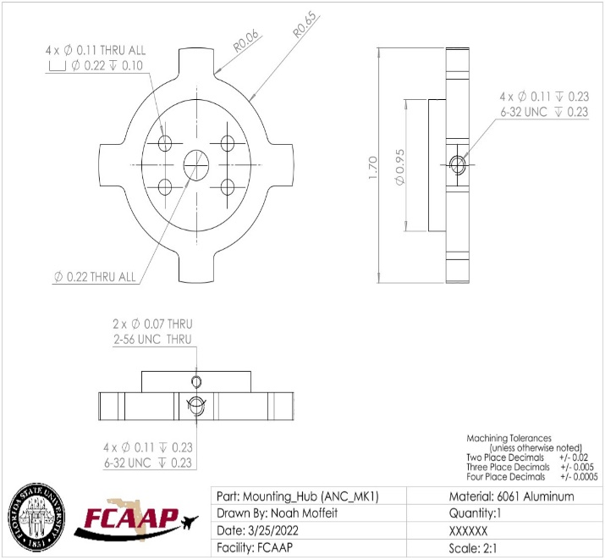
- Nose
The nose is the last component that is installed. To install the nose, simply screw it onto the thread of the rotation pin.
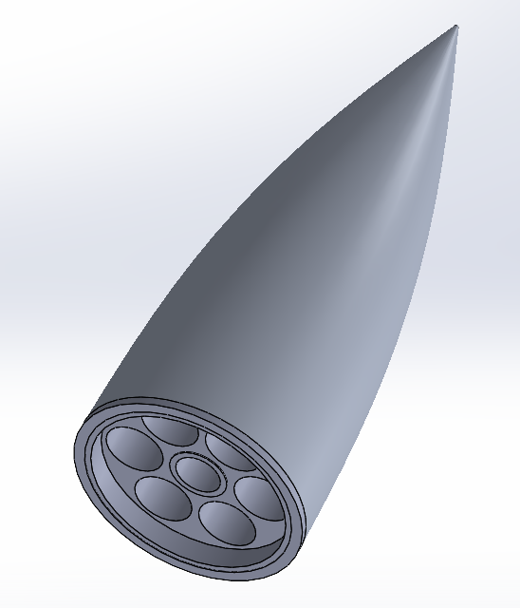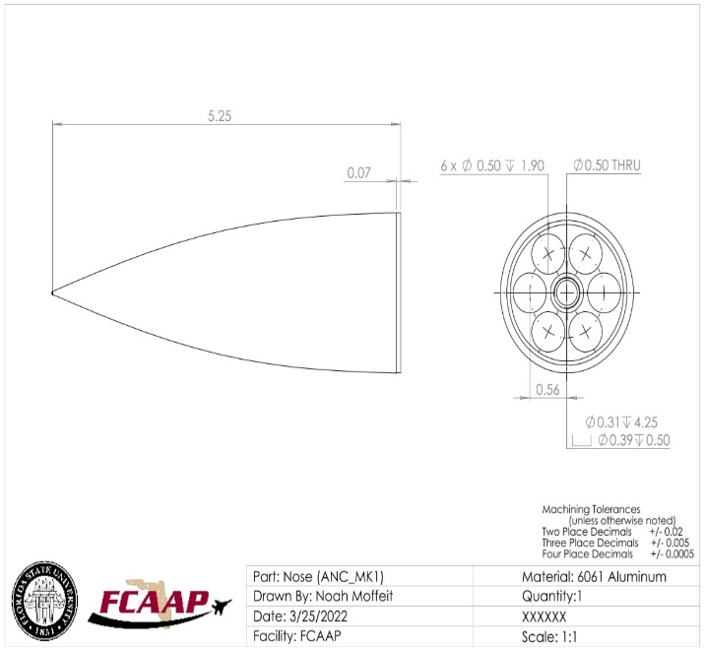
- Rear Deflecting Surface
The rear deflecting surface provides a 10-degree surface used to deflect the nose of the assembly. The flange of the component is covered by both bronze inserts after installation. The rear deflecting surface is placed over the cylindrical protrusion of the frontal motor mount and fastened down.
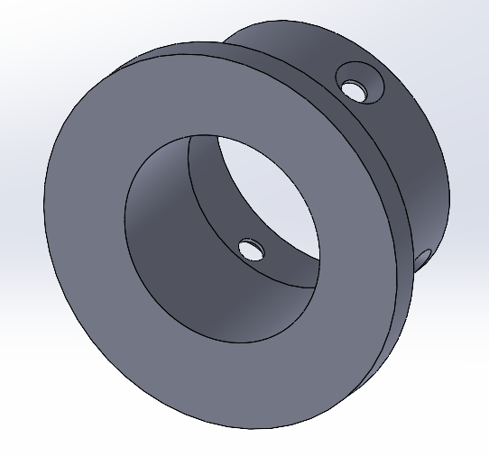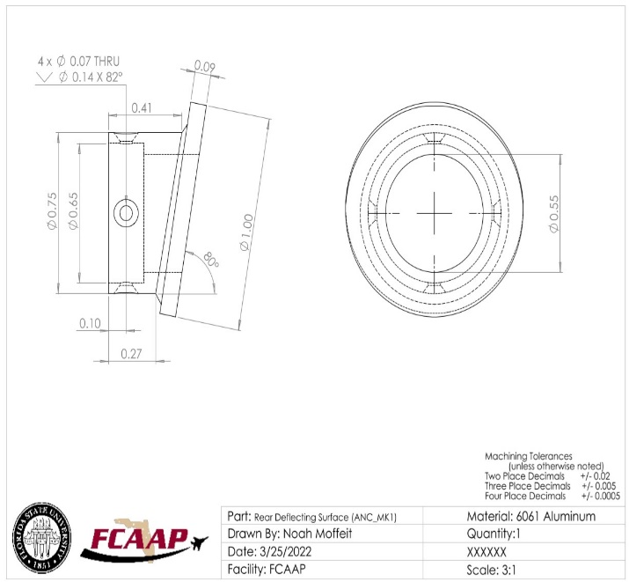
- Rotation Pin
The rotation pin is a specialized piece that connects to both the universal joint and threads into the nose cone. This piece needs to be inserted into the bottom of the frontal deflecting surface and then sandwich together with the bearing. At the end of the assembly, the nose cone will be screwed onto the threads at the end of the pin. This piece should be handled with care as its precise machining is critical to the rotational aspect of the assembly working.
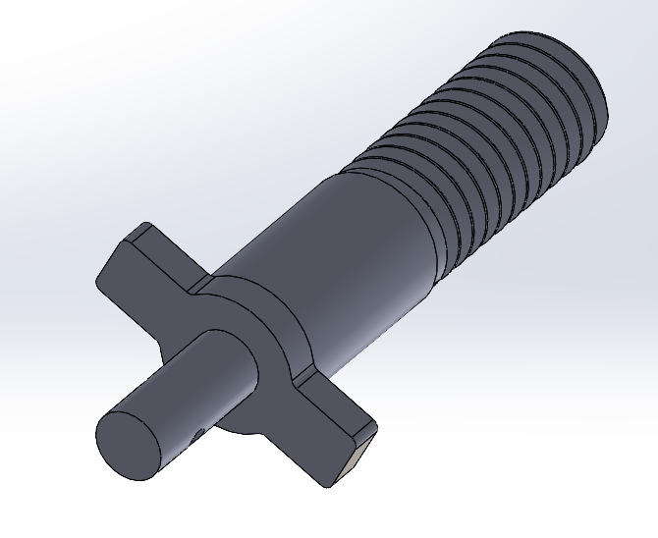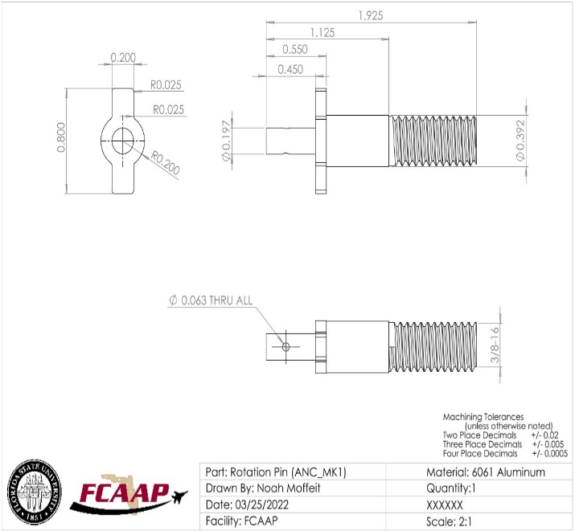
- Sleeve Cuff
The sleeve cuff exists to allow for the mounting of the sleeve around the model and attached to the crossed roller bearing in the nose. In doing so, it allowed for the skin to stay in line with the back body while the nose rotates around. It should be installed to the bearing before the nose cone is placed on the bearing.
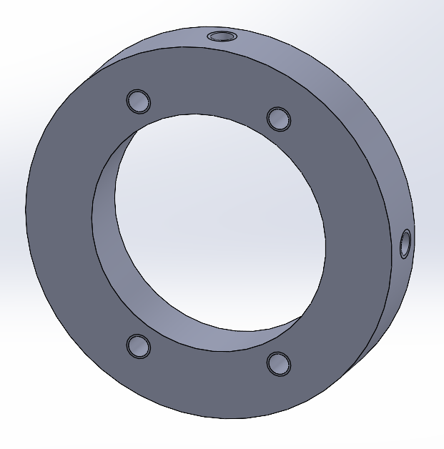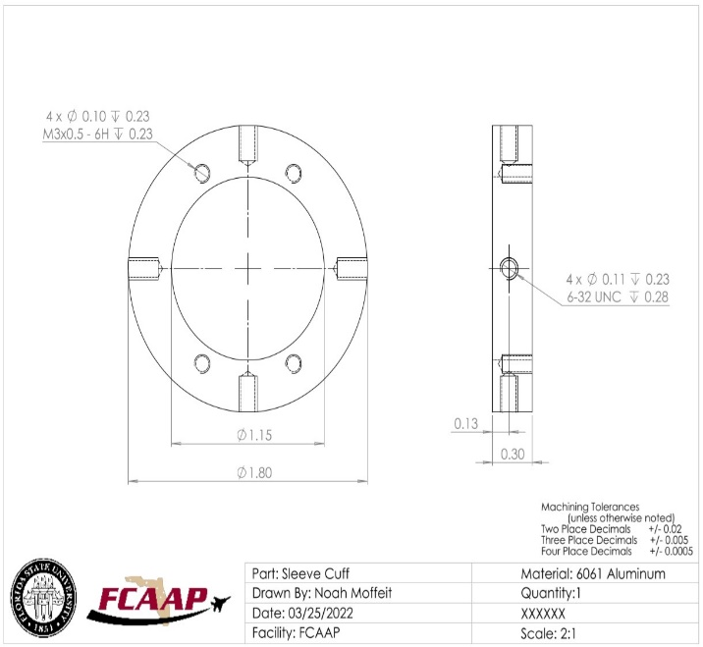

- Universal Joint
The universal joint is what allows the assembly to articulate the nose cone. It allows for the transmission of power that enables the nose cones rotation. It is connected to both the rotation pin and the pitch motor shaft. This joint should be installed when attaching the deflecting surfaces against each other. When doing so, it is important to make sure that both shafts fit properly into the joint. A spring pin is the inserted to hold it in place,
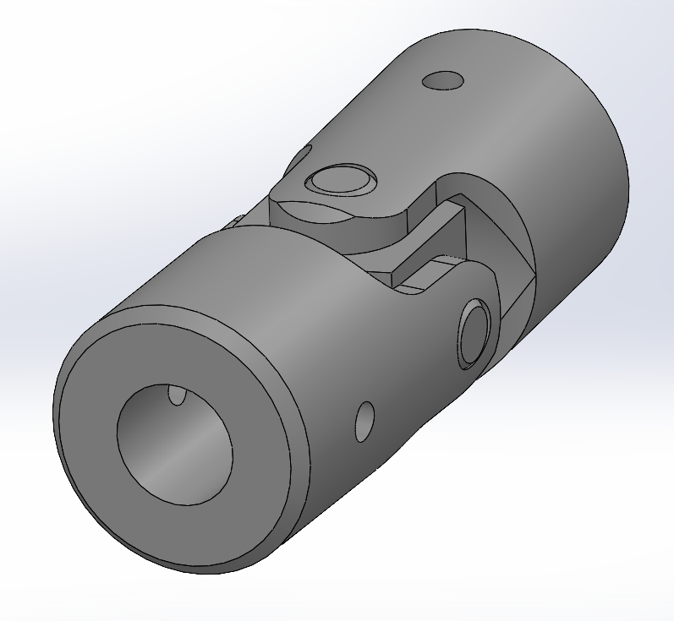

Integration
Integration of the motor control within the LabView VI interface allows for data acquisition to be run parallel to active use commanded motor control. This will be done using packages that allow for real time position control of the stepper motors in micro stepping mode to allow for the desired resolution to be achieved. The experimental setup used for testing is shown below.
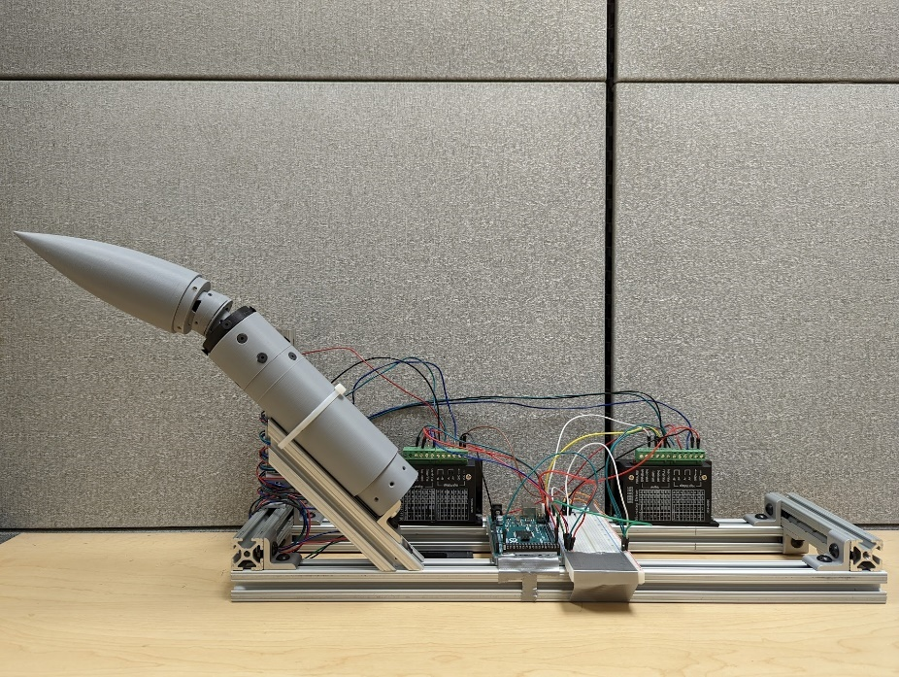
For this project, the wiring is not as bad as it seems. The model has 8 wires coming out of it. These are then screwed into the micro stepper drivers with the connections at the B-,B+,A-, and A+ ports displayed in the diagram below.
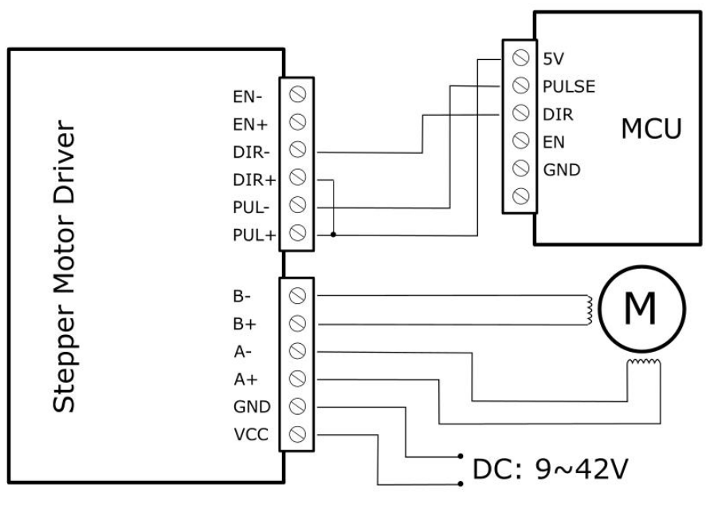
After wiring the motors to the micro controller, two wires need to be run from a 5-volt line from the Arduino microcontroller to both the PUL+ and DIR+ ports. Finally, the PUL- and DIR- ports are wired to two digital pins on the Arduino (4 total for both motors). Note these ports and what they are connected to on the microcontroller as these will be needed for use in the LabVIEW VI. Finally connect a ground wire to the ground port of both microcontrollers and use a power supply to provide the Vcc port with 8-9 Volts of power (whatever the minimum required is to enable the LED on the motor driver).

LabVIEW Code
It is worth noting that the code is still being continuously updated and the section is subject to change. The final version of the code will be saved to the DAQ computer in the low-speed tunnel in FCAAP.
LabVIEW programming is GUI based and not like a traditional coding language. It involved the connecting of lines to blocks to act as input and output parameters. The current code for LabVIEW is displayed below.
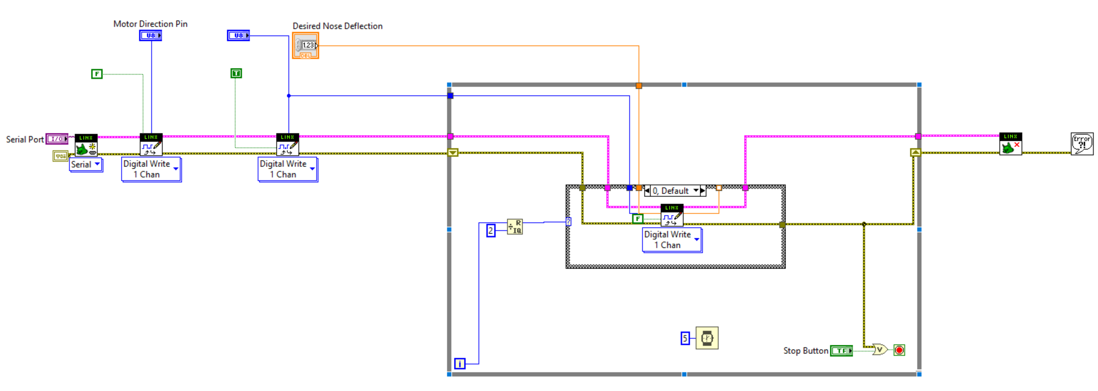
There main basis of this code revolved around a LabVIEW add-in called LINX. LINX allows for interfacing with the Arduino to control the stepper motors from LabVIEW. The functions take user input variables that are then passed into the LINX interface. Once the conditions have been determined from the user input, LabVIEW waits for a change to them (designated by the user pressing the enter key) and will run through a while loop to adjust the stepper motor position. In its current form, it does not interface with the data acquisition device in the wind tunnel. This will be added in the future and updated accordingly. Upon hitting the stop button, the program will revert to 0° and quit.
The stepper motors were tested and troubleshooted with an Arduino Mega 2560, and later transferred to the LabView program. Below is the preview for the code used for the calibration of the stepper motor position which allowed for the integration into LabView. This code can be opened by double clicking on the code and it will open in a new document. This can then be copy and pasted into the Arduino IDE. After the code is the state diagram used to program the Arduino code to determine which motors need to be running to obtain the desired deflection properties.
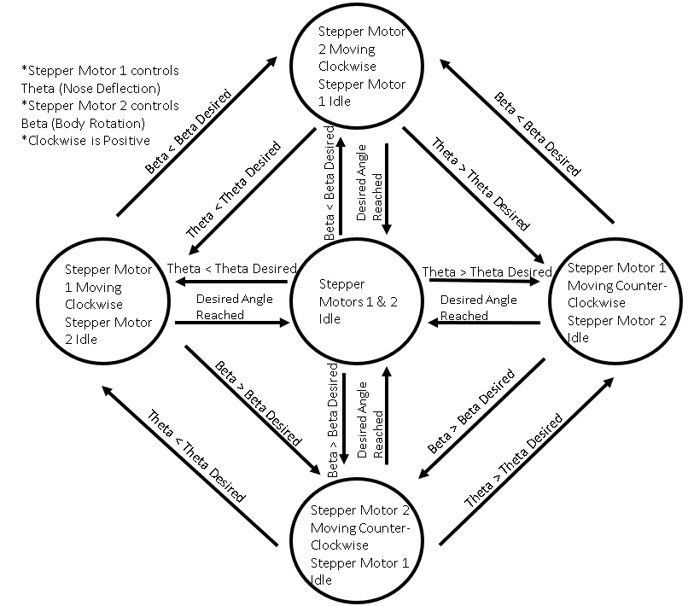

Operation
The operation of the nose cone was simplified for experimental purposes. This mechanism allows for the use to command a pitch angle, and the program will follow the best linear path possible to get to this angle. The user must only enter the desired angle of articulation and allow for the program to get there in the required time. Data Acquisition will run parallel to nose cone articulation, allowing for pertinent data related to the induced motion to be collected. The following LabVIEW VI is the current display the user will see.
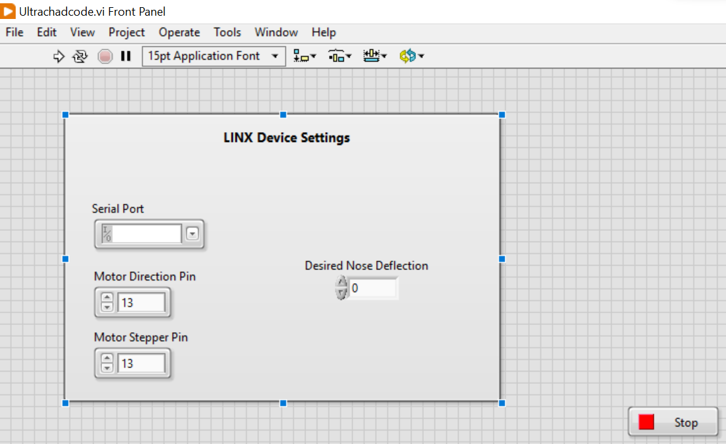
To use this interface, the user simply needs to specify the input pins noted earlier when connecting the microcontroller. In its current form, the interface only takes two pins, but it will soon be expanded to 4 to control both motors at the same time in which a roll option will also be added next to the desired nose deflection. Additionally, the user will need to connect a USB between their computer and the Arduino and select the COM port with their USB in the serial port dropdown menu. Assuming all the wiring is done correctly, the user just needs to hit the white run button and the hit enter after changing the properties in LabVIEW. This section will be updated as the code progresses.

Troubleshooting
If the program is not working, the first answer to restart the loop to allow for any state errors to be resolved. This can be done by stopping the program and executing again in LabView. The motor must be set back to the centerline position for the future readings from the LabView program to be accurate. This can be done inside of LabView with the correct operation and adjustment of the nose cone angle. Further than this, the stack exchange and the LabVIEW forums are some of the best places online to go for help. The people at the AME building are also very willing to assist in any problems that occur with the wind tunnel.

Appendix I: CAD Drawings
The following pages contain the CAD drawings for the machined parts of our project.
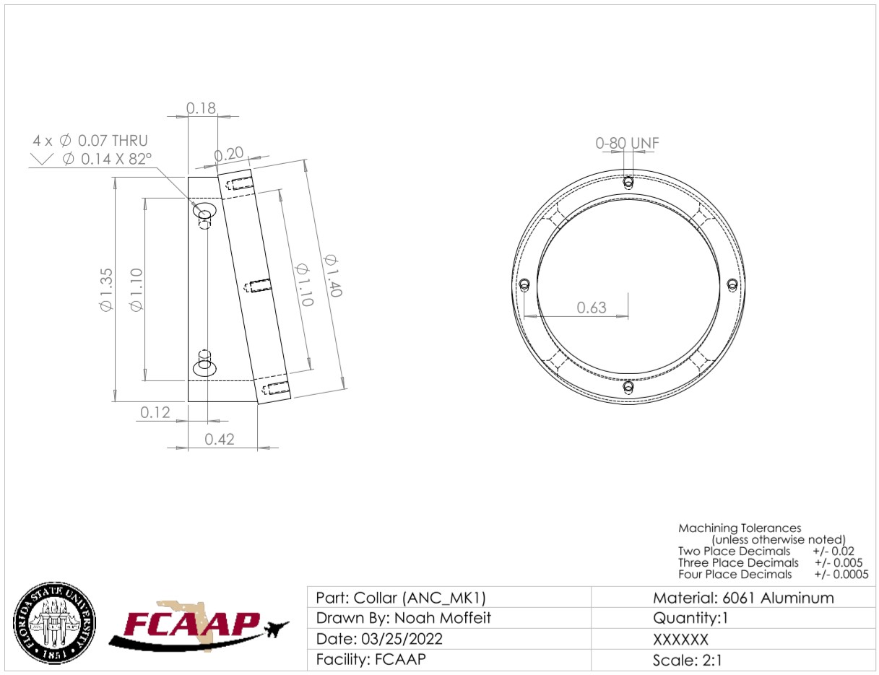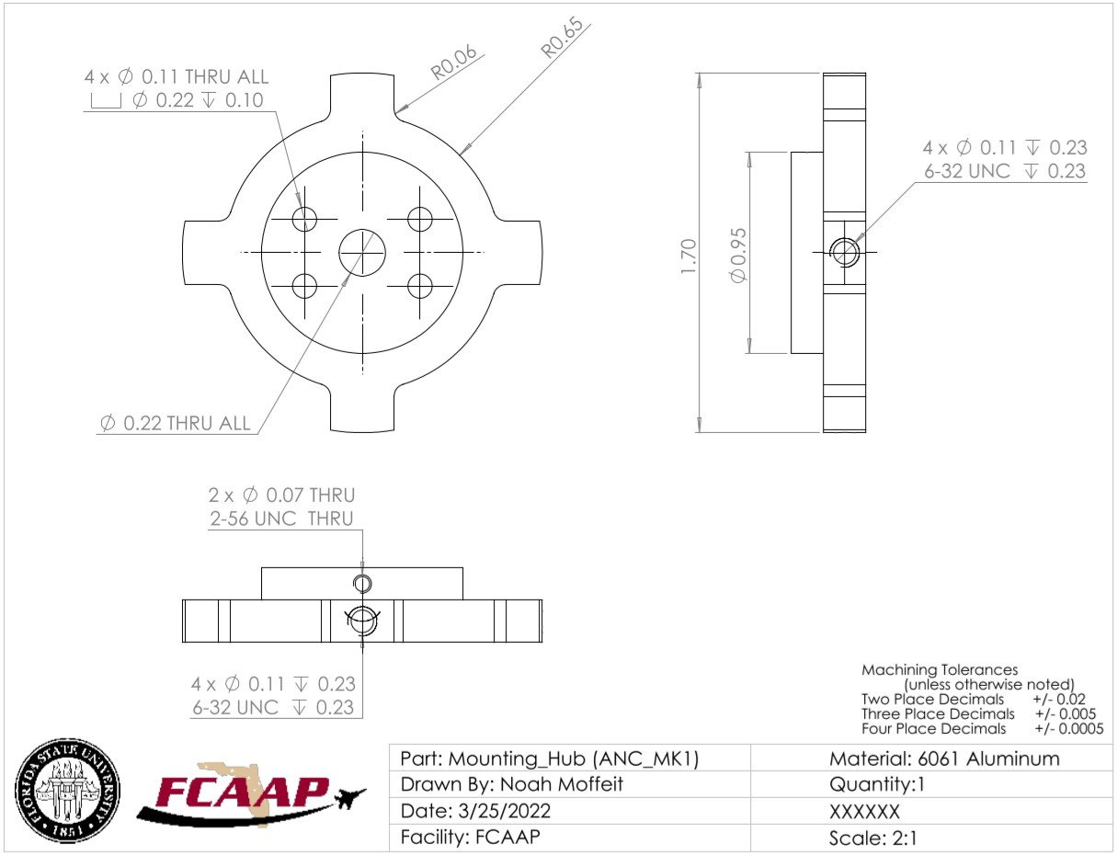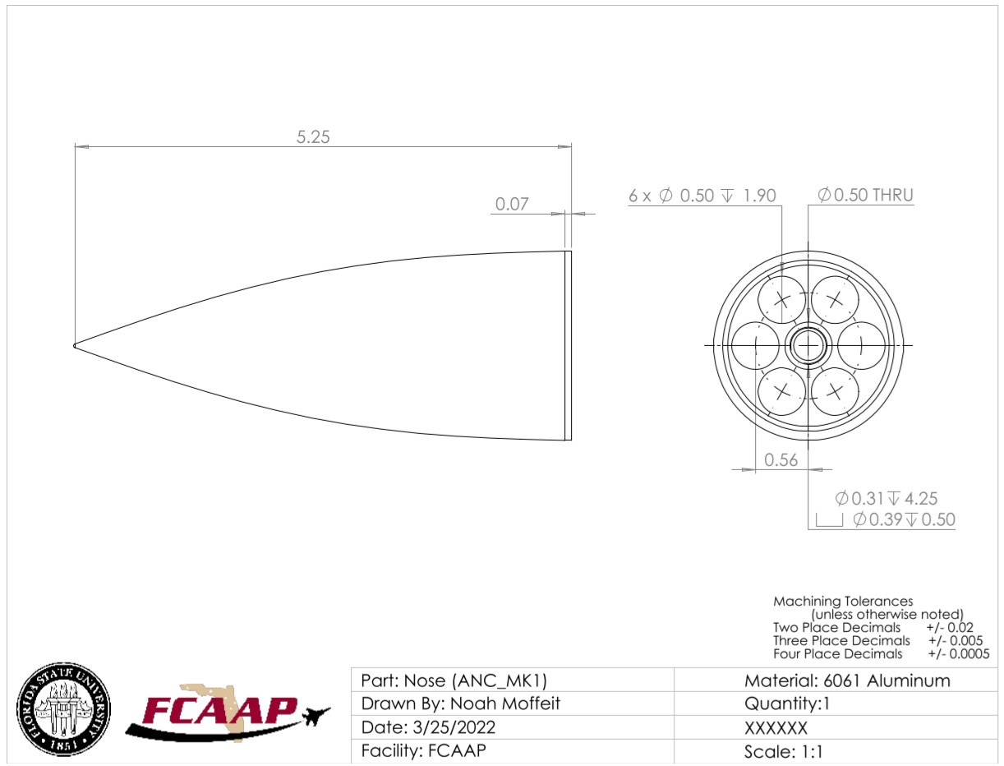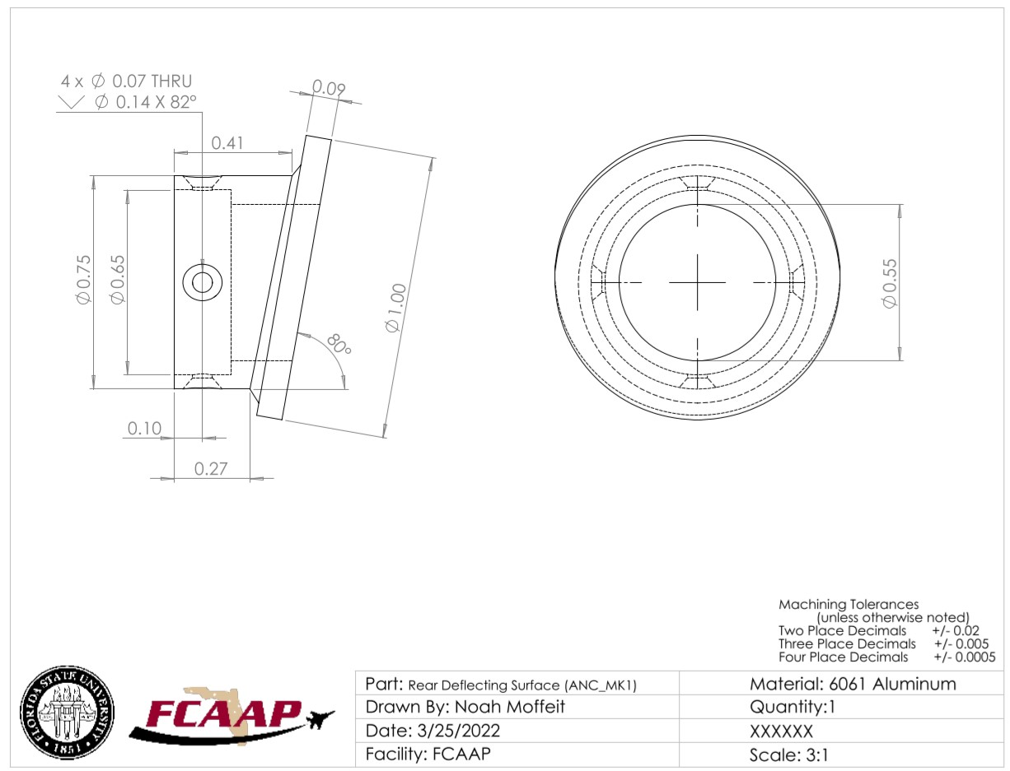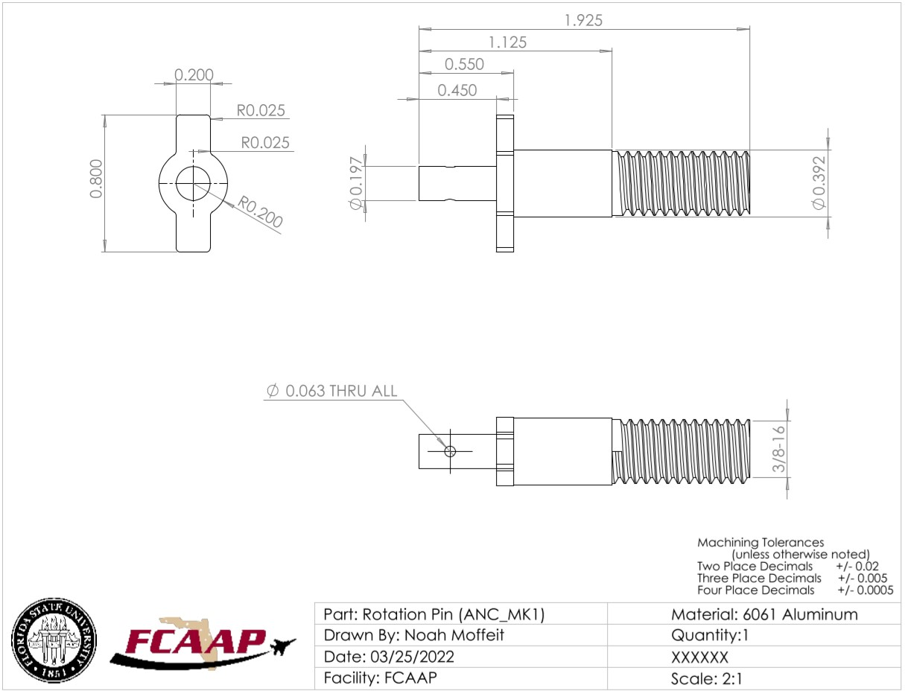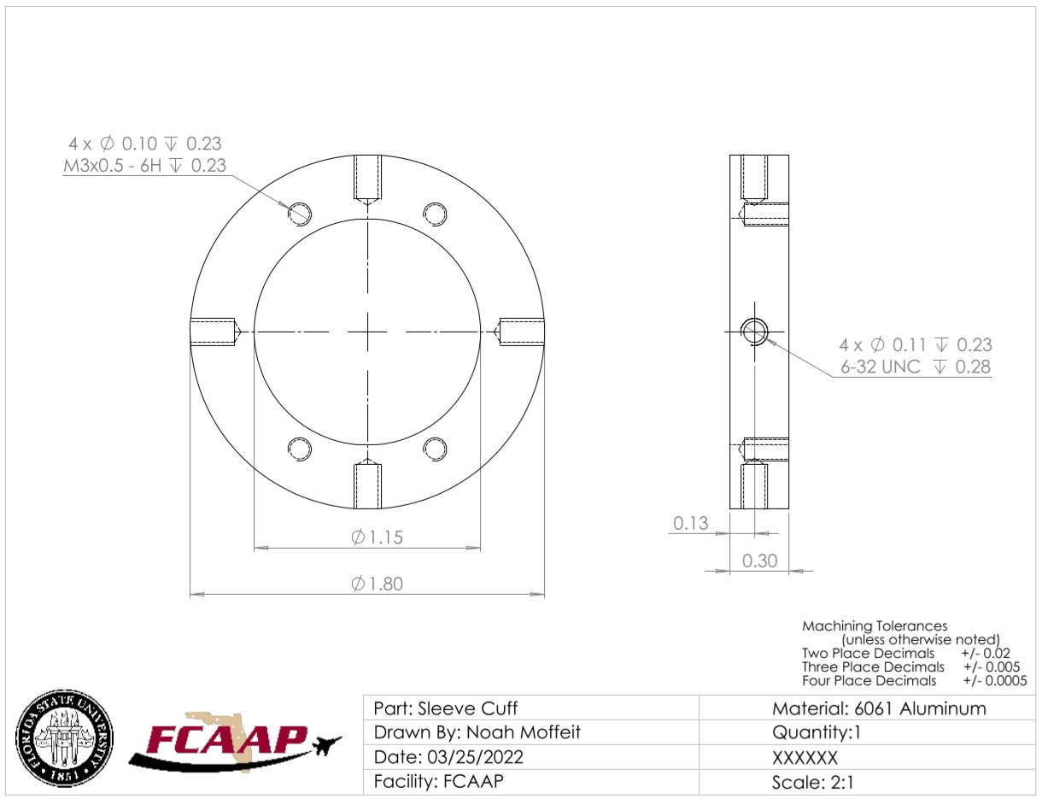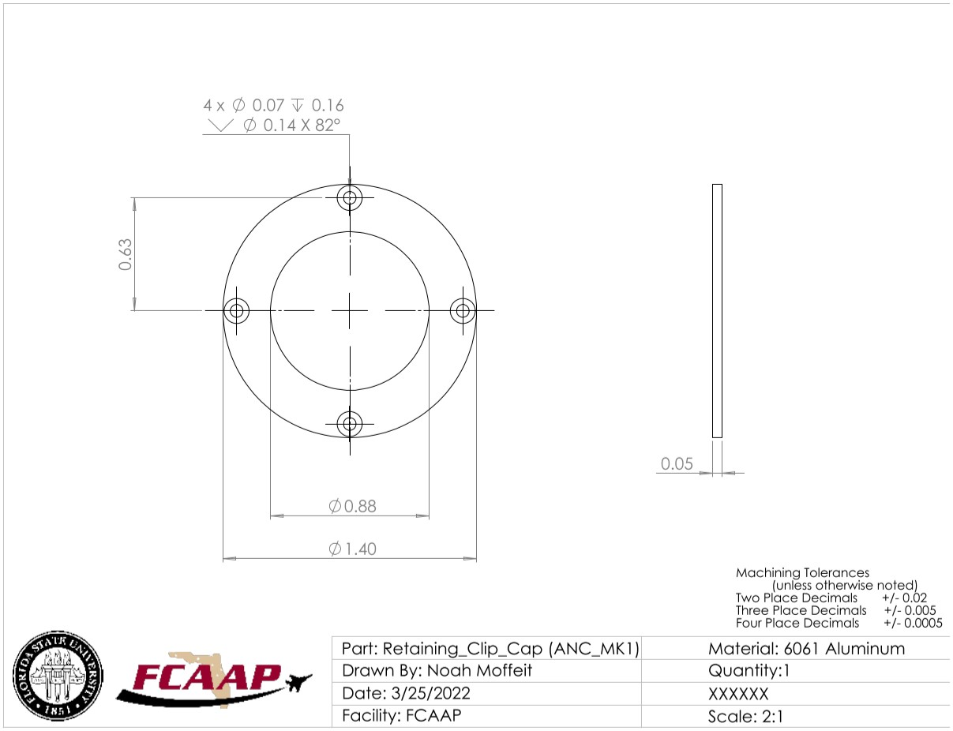

Appendix J: Spring Project Plan
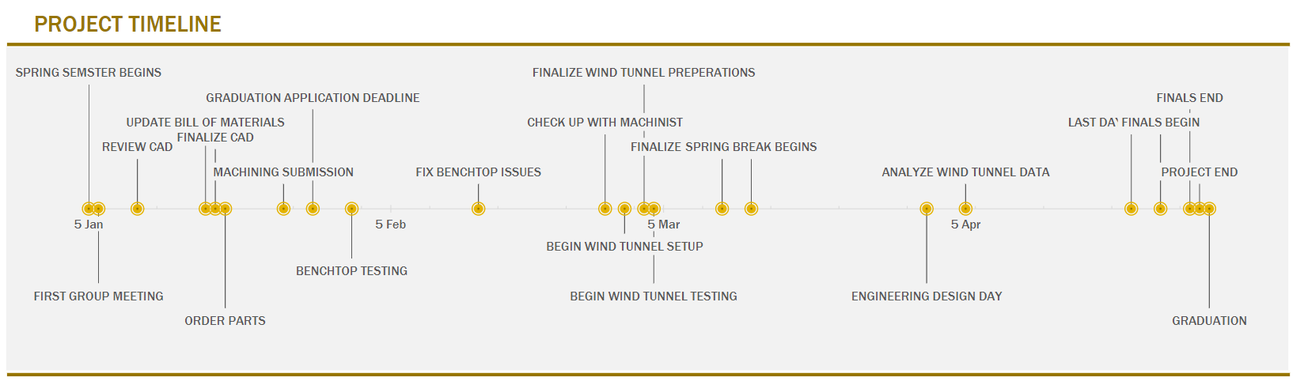

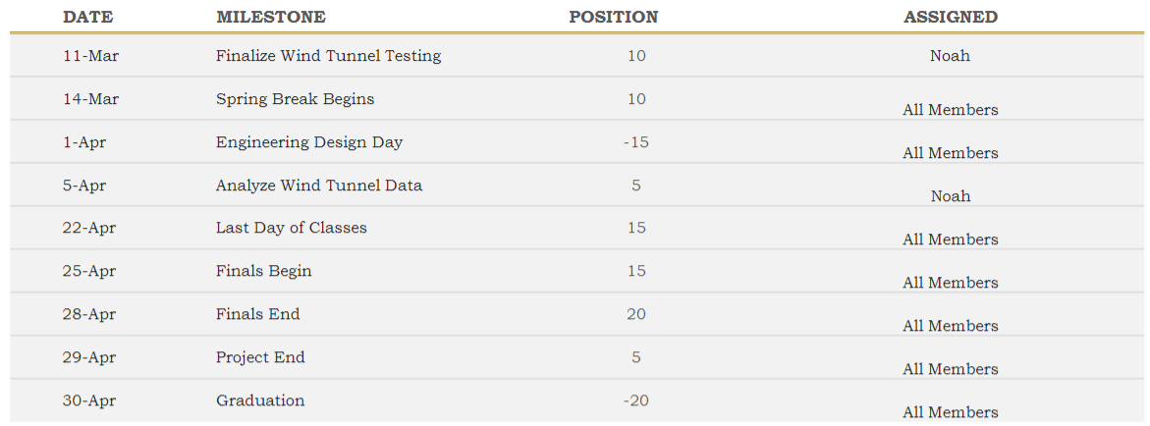

Appendix K: Risk Assessment
FAMU-FSU College of Engineering
Project Hazard Assessment Policy and Procedures
INTRODUCTION
University laboratories are not without safety hazards. Those circumstances or conditions that might go wrong must be predicted and reasonable control methods must be determined to prevent incident and injury. The FAMU-FSU College of Engineering is committed to achieving and maintaining safety in all levels of work activities.

PROJECT HAZARD ASSESSMENT POLICY
Principal investigator (PI)/instructor are responsible and accountable for safety in the research and teaching laboratory. Prior to starting an experiment, laboratory workers must conduct a project hazard assessment (PHA) to identify health, environmental and property hazards and the proper control methods to eliminate, reduce or control those hazards. PI/instructor must review, approve, and sign the written PHA and provide the identified hazard control measures. PI/instructor continually monitor projects to ensure proper controls and safety measures are available, implemented, and followed. PI/instructor are required to reevaluate a project anytime there is a change in scope or scale of a project and at least annually after the initial review.

PROJECT HAZARD ASSESSMENT PROCEDURES
It is FAMU-FSU College of Engineering policy to implement followings:
- Laboratory workers (i.e. graduate students, undergraduate students, postdoctoral, volunteers, etc.) performing a research in FAMU-FSU College of Engineering are required to conduct PHA prior to commencement of an experiment or any project change in order to identify existing or potential hazards and to determine proper measures to control those hazards.
- PI/instructor must review, approve and sign the written PHA.
- PI/instructor must ensure all the control methods identified in PHA are available and implemented in the laboratory.
- In the event laboratory personnel are not following the safety precautions, PI/instructor must take firm actions (e.g. stop the work, set a meeting to discuss potential hazards and consequences, ask personnel to review the safety rules, etc.) to clarify the safety expectations.
- PI/instructor must document all the incidents/accidents happened in the laboratory along with the PHA document to ensure that PHA is reviewed/modified to prevent reoccurrence. In the event of PHA modification a revision number should be given to the PHA, so project members know the latest PHA revision they should follow.
- PI/instructor must ensure that those findings in PHA are communicated with other students working in the same laboratory (affected users).
- PI/instructor must ensure that approved methods and precautions are being followed by :
- Performing periodic laboratory visits to prevent the development of unsafe practice.
- Quick reviewing of the safety rules and precautions in the laboratory members meetings.
- Assigning a safety representative to assist in implementing the expectations.
- Etc.
- A copy of this PHA must be kept in a binder inside the laboratory or PI/instructor’s office (if experiment steps are confidential).

Project Hazard Assessment Worksheet
PI/instructor: Rajan Kumar | Phone #: (850) 410-6331 | Dept.: FCAAP | Start Date: 11/19/2021 | Revision number:21
Project: SMART Projectile |  |  | Location(s): FAMU FSU College of Engineering (COE), Florida Center for Advanced Aero-Propulsion, Mechatronics, and Energy Building
Team member(s): Jed Fazler, Noah Moffeit, Nicholas Samuda, Robert Smith |  |  | Phone #: 509-999-2269 | Email:nem19d@my.fsu.edu
No changes were made during the second semester update. |  |  | 3/11/2022 | Revision 2

Experiment Steps | Location | Person assigned | Identify hazards or potential failure points | Control method | PPE | List proper method of hazardous waste disposal, if any. | Residual Risk | Specific rules based on the residual risk
Cutting/Machining | COE Machine Shop, FCAAP Machine Shop | Jed Fazler | Cuts, Scrapes, Crushing | Fabrication of parts for the project will primarily be done by the machine shops. Small scale alterations done by team members will be done following respective machine shop rules. | Safety Glasses, Ear Protection, Work Gloves | N/A | HAZARD: 3  CONSEQ: Significant | After approval by the PI, the Safety Committee and/or EHS must review and approve the completed PHA. A written Project Hazard Control is required and must be approved by the PI and the Safety Committee before proceeding. Two qualified workers must be in place before work can proceed. Limit the number of authorized workers in the hazard area.
 |  |  |  |  |  |  | RESIDUAL: Med High
Wiring/Soldering | FCAAP  COE  Senior Design Lab | Noah Moffeit | Electrocution,  Burns,  Hazardous Fumes | Testing of current with a Multimeter will be done before wiring. | Non-Conductive Work Gloves, Fume Fan, Rubber Soled Shoes | Any hazardous soldering material will be disposed of in the mechatronics lab | HAZARD: 2  CONSEQ: Significant | After approval by the PI, a copy must be sent to the Safety Committee. A written Project Hazard Control is required and must be approved by the PI before proceeding. A copy must be sent to the Safety Committee before proceeding. A second worker must be in place before work can proceed (buddy system). Limit the number of authorized workers in the hazard area
 |  |  |  |  |  |  | RESIDUAL: Medium
Coding and CAD | COE | Noah Moffeit | Back, neck, and shoulder pain. Eyestrain | Breaks will be taken when at the computer for long periods of time. | Blue Light Filtering Glasses | N/A | HAZARD: 1  CONSEQ: Negligible | Safety controls are planned by both the worker and supervisor. Proceed with supervisor authorization.
 |  |  |  |  |  |  | RESIDUAL: Low
3D Printing | COE Senior Design Lab | Robert Smith | Burns, Hazardous Fume Inhalation | If an enclosure is available for the 3D printer, it will remain closed throughout the printing process. After printing, wait at least 10 minutes before picking up parts. | N/A | N/A | HAZARD: 1  CONSEQ: Negligible | Safety controls are planned by both the worker and supervisor. Proceed with supervisor authorization.
 |  |  |  |  |  |  | RESIDUAL: Low
Projectile Assembly | FCAAP | Nicholas Samuda | Pinching, Cuts, Scrapes | Pieces with sharp edges should be wrapped until installation. | Safety Gloves | N/A | HAZARD: 2  CONSEQ: Minor | Safety controls are planned by both the worker and supervisor. A second worker must be in place before work can proceed (buddy system). Proceed with supervisor authorization.
 |  |  |  |  |  |  | RESIDUAL: Low Med
Particle Image Velocimetry Tests (PIV) | FCAAP Low Speed Tunnel | Robert Smith | Blinding, Burns, Hearing Loss | Apply FCAAP lab safety rules for when lasers are in use. | Eye Protection, Ear Protection | N/A | HAZARD: 3  CONSEQ: Significant | After approval by the PI, the Safety Committee and/or EHS must review and approve the completed PHA. A written Project Hazard Control is required and must be approved by the PI and the Safety Committee before proceeding. Two qualified workers must be in place before work can proceed. Limit the number of authorized workers in the hazard area.
 |  |  |  |  |  |  | RESIDUAL: Med High
Force Measurements | FCAAP Low Speed Tunnel | Noah Moffeit | Hearing Loss | Apply FCAAP lab safety rules. | Ear Protection | N/A | HAZARD: 2  CONSEQ: Moderate | Safety controls are planned by both the worker and supervisor. A second worker must be in place before work can proceed (buddy system). Proceed with supervisor authorization.
 |  |  |  |  |  |  | RESIDUAL: Low Med
Principal investigator(s)/ instructor PHA: I have reviewed and approved the PHA worksheet.
Name | Signature | Date | Name | Signature | Date
__________________________________ | ____________________ | ____________ | __________________________________ | ____________________ | ____________
Team members: I certify that I have reviewed the PHA worksheet, am aware of the hazards, and will ensure the control measures are followed.
Name | Signature | Date
Noah Moffeit | 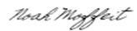 | 11/19/21
Robert Smith |  | 11/19/21
Nicholas Samuda | 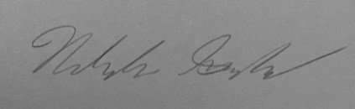 | 11/19/21
Jed Fazler | 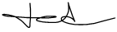 | 11/19/21
Copy this page if more space is needed.

DEFINITIONS:
Hazard: Any situation, object, or behavior that exists, or that can potentially cause ill health, injury, loss or property damage e.g. electricity, chemicals, biohazard materials, sharp objects, noise, wet floor, etc. OSHA defines hazards as “any source of potential damage, harm or adverse health effects on something or someone". A list of hazard types and examples are provided in appendix A.
Hazard control: Hazard control refers to workplace measures to eliminate/minimize adverse health effects, injury, loss, and property damage. Hazard control practices are often categorized into following three groups (priority as listed):
- Engineering control: physical modifications to a process, equipment, or installation of a barrier into a system to minimize worker exposure to a hazard. Examples are ventilation (fume hood, biological safety cabinet), containment (glove box, sealed containers, barriers), substitution/elimination (consider less hazardous alternative materials), process controls (safety valves, gauges, temperature sensor, regulators, alarms, monitors, electrical grounding and bonding), etc.
- Administrative control: changes in work procedures to reduce exposure and mitigate hazards. Examples are reducing scale of process (micro-scale experiments), reducing time of personal exposure to process, providing training on proper techniques, writing safety policies, supervision, requesting experts to perform the task, etc.
- Personal protective equipment (PPE): equipment worn to minimize exposure to hazards. Examples are gloves, safety glasses, goggles, steel toe shoes, earplugs or muffs, hard hats, respirators, vests, full body suits, laboratory coats, etc.
Team member(s): Everyone who works on the project (i.e. grads, undergrads, postdocs, etc.). The primary contact must be listed first and provide phone number and email for contact.
Safety representative: Each laboratory is encouraged to have a safety representative, preferably a graduate student, in order to facilitate the implementation of the safety expectations in the laboratory. Duties include (but are not limited to):
- Act as a point of contact between the laboratory members and the college safety committee members.
- Ensure laboratory members are following the safety rules.
- Conduct periodic safety inspection of the laboratory.
- Schedule laboratory clean up dates with the laboratory members.
- Request for hazardous waste pick up.
Residual risk: Residual Risk Assessment Matrix are used to determine project’s risk level. The hazard assessment matrix (table 1) and the residual risk assessment matrix (table2) are used to identify the residual risk category.
The instructions to use hazard assessment matrix (table 1) are listed below:
- Define the workers familiarity level to perform the task and the complexity of the task.
- Find the value associated with familiarity/complexity (1 – 5) and enter value next to: HAZARD on the PHA worksheet.
Table 1. Hazard assessment matrix.
 |  | Complexity
 |  | Simple | Moderate | Difficult
Familiarity Level | Very Familiar | 1 | 2 | 3
 | Somewhat Familiar | 2 | 3 | 4
 | Unfamiliar | 3 | 4 | 5

The instructions to use residual risk assessment matrix (table 2) are listed below:
- Identify the row associated with the familiarity/complexity value (1 – 5).
- Identify the consequences and enter value next to: CONSEQ on the PHA worksheet. Consequences are determined by defining what would happen in a worst case scenario if controls fail.
- Negligible: minor injury resulting in basic first aid treatment that can be provided on site.
- Minor: minor injury resulting in advanced first aid treatment administered by a physician.
- Moderate: injuries that require treatment above first aid but do not require hospitalization.
- Significant: severe injuries requiring hospitalization.
- Severe: death or permanent disability.
- Find the residual risk value associated with assessed hazard/consequences: Low –Low Med – Med– Med High – High.
- Enter value next to: RESIDUAL on the PHA worksheet.
Table 2. Residual risk assessment matrix.
Assessed Hazard Level | Consequences
 | Negligible | Minor | Moderate | Significant | Severe
5 | Low Med | Medium | Med High | High | High
4 | Low | Low Med | Medium | Med High | High
3 | Low | Low Med | Medium | Med High | Med High
2 | Low | Low Med | Low Med | Medium | Medium
1 | Low | Low | Low Med | Low Med | Medium

Specific rules for each category of the residual risk:
Low:
- Safety controls are planned by both the worker and supervisor.
- Proceed with supervisor authorization.
Low Med:
- Safety controls are planned by both the worker and supervisor.
- A second worker must be in place before work can proceed (buddy system).
- Proceed with supervisor authorization.
Med:
- After approval by the PI, a copy must be sent to the Safety Committee.
- A written Project Hazard Control is required and must be approved by the PI before proceeding. A copy must be sent to the Safety Committee.
- A second worker must be in place before work can proceed (buddy system).
- Limit the number of authorized workers in the hazard area.
Med High:
- After approval by the PI, the Safety Committee and/or EHS must review and approve the completed PHA.
- A written Project Hazard Control is required and must be approved by the PI and the Safety Committee before proceeding.
- Two qualified workers must be in place before work can proceed.
- Limit the number of authorized workers in the hazard area.
High:
- The activity will not be performed. The activity must be redesigned to fall in a lower hazard category.

Appendix A: Hazard types and examples
Types of Hazard | Example
Physical hazards | Wet floors, loose electrical cables objects protruding in walkways or doorways
Ergonomic hazards | Lifting heavy objects Stretching the body  Twisting the body  Poor desk seating
Psychological hazards | Heights, loud sounds, tunnels, bright lights
Environmental hazards | Room temperature, ventilation contaminated air, photocopiers, some office plants acids
Hazardous substances | Alkalis solvents
Biological hazards | Hepatitis B, new strain influenza
Radiation hazards | Electric welding flashes Sunburn
Chemical hazards | Effects on central nervous system, lungs, digestive system, circulatory system, skin, reproductive system. Short term (acute) effects such as burns, rashes, irritation, feeling unwell, coma and death.  Long term (chronic) effects such as mutagenic (affects cell structure), carcinogenic (cancer), teratogenic (reproductive effect), dermatitis of the skin, and occupational asthma and lung damage.
Noise | High levels of industrial noise will cause irritation in the short term, and industrial deafness in the long term.
Temperature | Personal comfort is best between temperatures of 16°C and 30°C, better between 21°C and 26°C.  Working outside these temperature ranges: may lead to becoming chilled, even hypothermia (deep body cooling) in the colder temperatures, and may lead to dehydration, cramps, heat exhaustion, and hyperthermia (heat stroke) in the warmer temperatures.
Being struck by | This hazard could be a projectile, moving object or material. The health effect could be lacerations, bruising, breaks, eye injuries, and possibly death.
Crushed by | A typical example of this hazard is tractor rollover. Death is usually the result
Entangled by | Becoming entangled in machinery. Effects could be crushing, lacerations, bruising, breaks amputation and death.
High energy sources | Explosions, high pressure gases, liquids and dusts, fires, electricity and sources such as lasers can all have serious effects on the body, even death.
Vibration | Vibration can affect the human body in the hand arm with `white-finger' or Raynaud's Syndrome, and the whole body with motion sickness, giddiness, damage to bones and audits, blood pressure and nervous system problems.
Slips, trips and falls | A very common workplace hazard from tripping on floors, falling off structures or down stairs, and slipping on spills.
Radiation | Radiation can have serious health effects. Skin cancer, other cancers, sterility, birth deformities, blood changes, skin burns and eye damage are examples.
Physical | Excessive effort, poor posture and repetition can all lead to muscular pain, tendon damage and deterioration to bones and related structures
Psychological | Stress, anxiety, tiredness, poor concentration, headaches, back pain and heart disease can be the health effects
Biological | More common in the health, food and agricultural industries. Effects such as infectious disease, rashes and allergic response.

Project Hazard Control- For Projects with Medium and Higher Risks
Name of Project: SMART Projectile |  |  |  | Date of submission: November 19th, 2021
Team Member |  | Phone number |  | Email
Jed Fazler |  | (941) 830-5050 |  | jef18c@my.fsu.edu
Noah Moffeit |  | (509) 999-2269 |  | nem19d@my.fsu.edu
Nicholas Samuda |  | (407) 719-3209 |  | nas19k@my.edu.edu
Robert Smith |  | (850) 264-5915 |  | rds18b@my.fsu.edu
Faculty Mentor |  | Phone number |  | Email
Dr. Rajan Kumar |  | (850) 645-0149 |  | rkumar@fsu.edu
Dr. Jonas Gustavsson |  | (850) 410-6335 |  | jgustavsson@eng.famu.fsu.edu
Rewrite the project steps to include all safety measures taken for each step or combination of steps. Be specific (don’t just state “be careful”).
Cutting/Machining: The fabrication of most parts for the assembly will be done by professionals at the machine shop. Any small alterations conducted by team members will be done while wearing the proper safety wear and with supervision.
Wiring/Soldering: Before wiring will be done, it must first be determined that no power is provided to the system. This will be done by testing the current with a multimeter. Gloves will be worn when soldering with hazardous materials and a fume fan will be on at all times.
Coding and CAD: To avoid eyestrain or back pain, breaks will be conducted when using a computer for times longer than 30 minutes.
3D Printing: To minimize burn risks, wear gloves when handling prints and avoid reaching inside the printer unless certain it is off. 3D printing should only be done in a well-ventilated area.
Project Assembly: Many pieces of the assembly may have sharp corners or edges. To avoid cuts and scrapes, all parts will be wrapped during transportation. Protective gloves should also be worn at all times.
PIV and Force Measurements: During wind tunnel testing, noises can reach very high levels depending on the conditions being ran. To avoid damage to hearing, ear protection should be worn while the tunnel is running. PIV tests require the use of a class 4 laser. Class 4 lasers can cause significant damage to the eyes whether it is directed or reflected. To avoid injury, protective glasses should be worn any time the laser is powered on and skin exposure should be avoided.
3/11/2022 Update: No changes were made for revising.
Thinking about the accidents that have occurred or that you have identified as a risk, describe emergency response procedures to use.
- Call the appropriate authority
- Assess the scene and put on suitable protective equipment if applicable
- Address possible dangers if possible (i.e. turn off machinery, shut down wind tunnel)
- Provide first aid if properly trained
- Assist emergency services in finding the scene and provide any requested information
- Report the accident to the PI
List emergency response contact information:
- Call 911 for injuries, fires or other emergency situations
- Call your department representative to report a facility concern
Name | Phone number |  | Faculty or other COE emergency contact |  | Phone number
Jed Fazler | (941) 830-5050 |  | Keith Larson |  | (850) 410-6108
Noah Moffeit | (509) 999-2269 |  | Dr. Rajan Kumar |  | (850) 645-0149
Nicholas Samuda | (407) 719-3209 |  | Dr. Mohd Ali |  | (850) 410-6588
Robert Smith | (850) 264-5915 |  | Dr. Jonas Gustavsson |  | (850) 410-6335
Safety review signatures
Team member | Date |  | Signatures
Noah Moffeit | 11/19/21
Robert Smith | 11/19/21
Nicholas Samuda | 11/19/21 |  | 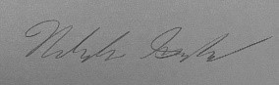
Jed Fazler | 11/19/21
Report all accidents and near misses to the faculty mentor.

Appendix L: Calculations
The following equations are to be used during testing to determine the aerodynamic characteristics of the model.
Dynamic Pressure:q∞=12ρV2
Lift Coefficient:CL=Lq∞S
Drag Coefficient:CD=Dq∞S
Moment Coefficient:CM=Mq∞SLref

